Pupil premium strategy statement – Ace Schools
This statement details our school’s use of pupil premium (and recovery premium) funding to help improve the attainment of our disadvantaged pupils.
It outlines our pupil premium strategy, how we intend to spend the funding in this academic year and the outcomes for disadvantaged pupils last academic year.

School overview
Detail | Data
Number of pupils in school | 337 (09/10/24)
Proportion (%) of pupil premium eligible pupils | 42%
Academic years that our current pupil premium strategy plan covers | 2022/2023 to  2024/2025
Date this statement was published | December 2025
Date on which it will be reviewed | December 2026
Statement authorised by | Ruth Westwood
Pupil premium lead | Ricky Richards
Governor / Trustee lead | Carole Burgoyne

Funding overview
Detail | Amount
Pupil premium funding allocation this academic year | £1,480 per pupil in Reception to Year 6 (FSM Ever 6)  £1,050 per pupil in Year 7 to Year 11 (FSM Ever 6)
Recovery premium funding allocation this academic year | £ 0
Pupil premium (and recovery premium) funding carried forward from previous years | £0
Total budget for this academic year | £146,468.00

Part A: Pupil premium strategy plan

Statement of intent
At ACE, our ambition is clear: no child is left behind. Our Pupil Premium Strategy is designed to address the significant and varied barriers our pupils face. Through rigorous tracking, careful planning and targeted support, we aim to ensure that every child has access to meaningful opportunities that enable academic success and personal growth.
Our planned Pupil Premium spending is firmly rooted in research-informed practice, alongside personalised intervention, in order to:
- Close academic gaps
- Provide therapeutic and emotional support
- Develop personal skills and character
- Build resilience
- Address the impact of exclusion
- Ensure high-quality, inclusive teaching
The barriers faced by pupils at ACE are often complex and multifaceted. Our strategy is both ambitious and aspirational, with a clear focus on enabling every pupil to:
- Achieve their potential
- Make strong and sustained progress
- Close attainment gaps
- Secure meaningful qualifications
- Progress to an appropriate and sustained post-16 pathway
While our strategy is centred on the needs of disadvantaged pupils, the approaches implemented — particularly those focused on high-quality teaching and whole-school provision — are designed to benefit all pupils. Implicit within the intended outcomes is our commitment to improving outcomes for non-disadvantaged pupils alongside their disadvantaged peers, ensuring equity and excellence across the provision.

Challenges
This details the key challenges to achievement that we have identified among our disadvantaged pupils.
Challenge number | Detail of challenge
1 | Negative impact on progress caused by limited self-regulation skills from students
2 | Poor levels of literacy and numeracy, compounded by gaps in learning due to low attendance, moving schools etc
3 | Poor attendance levels
4 | High levels of Social, Emotional, and Mental Health problems.
5 | Lacking cultural capital and low aspirations for future destinations.
6 | Cost of living crisis harming disadvantaged students in education

Intended outcomes
This explains the outcomes we are aiming for by the end of our current strategy plan, and how we will measure whether they have been achieved.
Intended outcome | Success criteria
Improve pupil behaviour for learning and engagement in lessons in order to impact positively on progress and improve the proportion of students achieving 4+ / 5+ in English, Maths and science. | - Increase students achieving 4+ in English & Maths from 46.5% to at least 50%  - Increase students achieving 4+ in English, Maths & Science from 36% to at least 40%  - Increase students achieving 4+ GCSEs from 40.7% to 45%  - Increase students achieving 5+ GCSEs from 17.4% to at least 22–25%  - Increase students achieving any GCSE from 64% to at least 70%  - Reduce behaviour incidents for PP pupils by at least 10%  - Behaviour for PP in line with whole-school average  - Increased parental engagement evidenced through improved attendance at meetings
Improve literacy and numeracy levels so that pupils are able to access the whole curriculum | - Increase the proportion of pupils reading at or above chronological age from current baseline to at least 60% (towards 70% longer-term goal).  - Increase students achieving 4+ in English & Maths from 46.5% to at least 50%.  - Increase students achieving 4+ in English, Maths & Science from 36% to at least 40%.  - PP pupils to make progress in English and Maths in line with or exceeding whole-school average progress measures.  - Reduce the proportion of pupils reading more than 12 months below chronological age.
Improve attendance levels | - Students will achieve, or exceed, attendance percentages in line with national averages  - Increased parental engagement demonstrated through home visits log.  - Attendance matters tracked consistently through Team Around the Pupil (TAM) meetings.
Provide meaningful support to pupils with Social Emotional Mental Health problems. | - All students complete a Motional profile  - Interventions show impact through engagement in learning.  - RRS scores improve showing an improvement in pupils’ skills in self- regulation.  - Students report positive influence of wellbeing in TAM reviews
Cultivate opportunities for enhancing ‘cultural capital’ through enrichment and experience. To improve aspirations in order to secure post 16 destinations. | - 100% of students complete the Skills Builder programme, with measurable improvement in at least 4 of the 8 core skill areas (as evidenced by assessment data).  - Increase KS4 pupils attending a vocational placement from 60% to at least 70%.  - 100% of PP Year 11 pupils attend at least one documented meeting with the Careers & Skills Worker (CSW), with an agreed post-16 plan recorded.  - Reduce NEET for PP pupils so it is at or below national AP average at October tracking point.  - At least 90% of PP pupils secure a confirmed post-16 destination by the end of Year 11.

Activity in this academic year
This details how we intend to spend our pupil premium (and recovery premium) funding this academic year to address the challenges listed above.

Teaching (for example, CPD, recruitment and retention)
Budgeted cost: £31796
Activity | Evidence that supports this approach | Challenge number(s) addressed
Core 6 | There is evidence to suggest that feedback involving metacognitive and self- regulatory approaches may have a greater impact on disadvantaged pupils and lower prior attainers than other pupils ( EEF 2020). | 2 - 4
CPD for Trauma Informed | PP pupils require more specialist support to help manage their self-regulation or social and emotional skills. Using a trauma informed approach when working with pupils helps them to develop these skills. (EEF 2020). | 4
Hire 3x lead learning mentors which support and upskill new, and existing, members of staff | The effective deployment of Teaching Assistants (TAs) can bolster schools’ attempts to close the attainment gap. (EEF, 2020) Our practice focus is specifically towards CPD for learning mentors. | 1,2
Using blended learning to support gaps caused by Covid 19 Lockdowns. | Digital technology can add up to +4 months progress (EEF, 2020) | 2
Weekly CPD and Twilight Sessions input- Oracy Focus | From the EEF toolkit this supports; Mastery learning Measured using:  - Monitoring of teaching and learning  - Pupil progress data  - Performance development | 2,4,5

Targeted academic support (for example, tutoring, one-to-one support structured interventions)
Budgeted cost: £54.620
Activity | Evidence that supports this approach | Challenge number(s) addressed
Academic mentor to support key students. | Evidence indicates that one to one tuition can be effective, delivering approximately five additional months’ progress on average. (EEF 2020) | 3
Offer vocational placements to KS4 students. | Some studies have shown that most young people already have high aspirations, suggesting that much underachievement results not from low aspiration but from a gap between aspirations and the knowledge, skills, and characteristics required to achieve them. (EEF 2020)  Offering a vocational placement allows students to develop and raise their skills level and knowledge to be in-line with their aspirations. | 5
Academic Intervention and tuition | Evidence indicates that one to one tuition can be effective, delivering approximately five additional months’ progress on average. (EEF 2020) | 2, 3
Salford Reading and Comprehension Test used to track pupil progress and direct to targeted and evidence-based interventions. | "Our biggest concern will be around identifying gaps in learning so schemes can respond to student need in a student-centred approach. These assessments allow us to do this, as and when our students are ready."  Bernadette Kaye, Literacy & Evidence Informed Project  Lead, South Shore Academy  Regular tracking will enable us to rapidly diminish differences in reading ages of PP pupils. | 3
Daily reading initiative | Reading for pleasure has social benefits as well and can make people feel more connected to the wider community. Reading increases a person's understanding of their own identity, improves empathy and gives them an insight into the world view of others (The Reading Agency 2015). | 2
Fresh start- Reading intervention | “Fresh Start has been tested through a previous EEF efficacy trial involving ten secondary schools and 433 Year 7 pupils. The study randomised pupils within each of the schools and focused particularly on pupils who did not achieve a level 4 on their Key Stage 2 SATs. The project found  a positive impact on all pupils of an additional three months’ progress over the course of an academic year.”  (Testing the impact of a systematic and rigorous phonics programme on early readers and also those that have fallen behind at the end of Key Stage 2, EEF 2020) | 2
Books and revision guides provided to students as part of year 11 strategy. | To facilitate independent study and engage parental support.  EEF suggest +8 months progress for metacognition and self-regulation. | 2

Wider strategies (for example, related to attendance, behaviour, wellbeing)
Budgeted cost: £60,062
Activity | Evidence that supports this approach | Challenge number(s) addressed
Use and hire additional pastoral behaviour support workers to positively reinforce attitude to learning. | EEF Toolkit - +3  months for behaviour interventions and this will also benefit all pupils in  the classroom due to purposeful learning environment. | 1
Offer consistency through a whole school behaviour policy. | Creates a purposeful learning environment for all students.  Clear expectations and boundaries for students.  EEF Supporting Behaviour in Schools Guidance | 1
Ensure all identified PP students with poor attendance to school have access to interventions that support them on an individual basis e.g. rewards, mini-bus to pick up students, etc. | The attendance of PP students at school is significantly below National expectations.  Many PP students have significant social and emotional barriers to learning and are subject to external multiagency plans. | 4
Sustain a system of rewards and incentives for improved attendance to school.  Personalised rewards and recognition to ensure whole school profile raised. | The Department for Education (DfE) published research in 2016 which found that:  The higher the overall absence rate across Key Stage (KS) 2 and KS4, the lower the likely level of attainment at the end of KS2 and KS4  Pupils with no absence are 1.3 times more likely to achieve level 4 or above, and 3.1 times more likely to achieve level 5 or above, than pupils that missed 10-15% of all sessions  Pupils with no absence are 2.2 times more likely to achieve 5+ GCSEs A*- C or equivalent including English and mathematics than pupils that missed 15- 20% of KS4 lessons | 4
Improve family home school liaison and relationships by supporting potential attendance barriers such as food hardship. | Ensure parents of PP students feel safe and confident engaging with school. Home visits completed to engage the hard to reach.  Attendance Manager and year leads arrange appointments at all parent events.  EEF Toolkit Parental Engagement suggests +3 months progress. | 4,6

Reduce the number of Fixed Term Exclusions. | Disadvantaged student outcomes will not be improved if they lose valuable lesson time.  Disadvantaged students have a higher national percentage of exclusions. If they are excluded by the school, they have less chance of becoming productive members of society.  Measure attendance of groups (FT exclusions  — more than half are Year 9 and above) PP students are 4X more likely to receive FT exclusion (Peter Humphries Senior HMI Sec  Ed Pupil Premium Conference: 23/3/2018 | 1, 4
Offer subsided uniform | Pupils from lower socioeconomic households are less likely to be able to afford the cost of school uniforms. However, the impact that uniform has on learning or behaviour is unclear. (EEF 2020) | 4,6
Work with external agencies including CAMHS, Kooth and MASH to support pupils and families. | Ofsted expect to see learners’ attitudes to their education or training are positive. They are committed to their learning, know how to study effectively and do so, are resilient to setbacks and take pride in their achievements. 2021 | 4
Development of life skills through- Skills Builder | Metacognition and self-regulation strategies can be effective when taught in collaborative groups so that learners can support each other and make their thinking explicit through discussion. (EEF 2020) | 4

Total budgeted cost: £146,468.00

Part B: Review of the previous academic year

Outcomes for disadvantaged pupils
GCSE Results Comparison between 2022-2025
 | 2022 | 2023 | 2024 | 2025 | 2022 | 2023 | 2024 | 2025
No in cohort | 86 | 93 | 86 | 64 | 86 | 93 | 86 | 64
Achieved maths and Eng GCSE | 41 | 43 | 40 | 46 | 47.7% | 46.2% | 46.5% | 71.9%
Achieved maths, Eng and science GCSE | 36 | 35 | 31 | 34 | 41.9% | 37.6% | 36% | 53.1%
Achieved any GCSE | 70 | 63 | 55 | 64 | 81.4% | 67.7% | 64% | 100%
Achieved 3 or more GCSE | 50 | 44 | 39 | 45 | 58.1% | 47.3% | 45.3% | 70.3%
Achieved 4 or more GCSE | 43 | 39 | 35 | 43 | 50.0% | 41.9% | 40.7% | 67.2%
Achieved 5 or more GCSE | 30 | 27 | 15 | 11 | 34.9% | 29.0% | 17.4% | 17.2%
Achieved 6 or more GCSE | 17 | 9 | 8 | 2 | 19.8% | 9.7% | 9.3% | 3.1%
Achieved any English qual | 53 | 58 | 51 | 56 | 61.6% | 62.4% | 59.3% | 87.5%
Achieved any maths qual | 77 | 75 | 73 | 50 | 89.5% | 80.6% | 84.9% | 78.1%
Achieved any science qual | 68 | 60 | 53 | 40 | 79.1% | 64.5% | 61.6% | 62.5%
Outcomes in 2025 show a clear and significant improvement compared with the previous three years, particularly in the achievement of core GCSE subjects. The proportion of students achieving both Maths and English GCSEs increased to 46 students (71.9%), compared with 40 students (46.5%) in 2024 and 43 students (46.2%) in 2023, representing an increase of over 25 percentage points from the previous year. Similarly, the number of students achieving Maths, English and Science GCSEs rose to 34 students (53.1%) in 2025, up from 31 students (36.0%) in 2024 and 35 students (37.6%) in 2023, reversing the downward trend seen between 2022 and 2024.
Achievement of any GCSE also reached its strongest level across the four-year period, with 100% of students (64/64) achieving at least one GCSE in 2025, compared with 64.0% in 2024 and 67.7% in 2023. There was also an improvement in broader attainment, with 70.3% of students (45) achieving three or more GCSEs in 2025, up from 45.3% in 2024, and 67.2% (43 students) achieving four or more GCSEs, compared with 40.7% in 2024.
There has also been a marked increase in the proportion of students achieving any English qualification, rising to 87.5% (56 students) in 2025 from 59.3% in 2024 and 62.4% in 2023. This improvement reflects the impact of a strengthened curriculum offer and the continued use of alternative qualification pathways, including Step-up to English, which provides an Entry Level route focused on developing essential communication and life skills and supporting progression into further education, training and employment.
While the proportion of students achieving higher volumes of GCSEs (5+ and 6+) remains lower than in earlier years, the 2025 outcomes demonstrate a substantial strengthening in core subject success and inclusive access to qualifications, representing a highly positive step forward for the cohort.
Attendance
For 2023-2024 (62.4% attendance):
- Unauthorised absence: 16.9%
- Authorised absence: 20.7%
- Physical late: 2.0%
- Largest absence reasons: Unauthorised Absence (42.26%), Leave for exceptional circumstances (20.84%), Illness (15.73%), Study Leave (9.10%)

For 2024-2025 (60.4% attendance):
- Unauthorised absence: 13.7%
- Authorised absence: 25.9%
- Physical late: 2.3%
- Largest absence reasons: Unauthorised Absence (32.04%), Part-Time Timetable (27.6%), Illness (15.41%), Study Leave (8.13%)
Overall attendance decreased slightly from 62.4% in 2023–2024 to 60.4% in 2024–2025. However, this was accompanied by a positive shift in the pattern of absence. Unauthorised absence reduced from 16.9% to 13.7%, while authorised absence increased from 20.7% to 25.9%, indicating that a greater proportion of absence is now planned and agreed.
In 2023–2024, the main absence reasons were unauthorised absence (42.26%), leave for exceptional circumstances (20.84%) and illness (15.73%). In 2024–2025, unauthorised absence fell to 32.04%, while part-time timetables increased to 27.6%, reflecting a more structured approach to supporting vulnerable pupils. This suggests that although overall attendance has declined slightly, absence is increasingly managed through appropriate and monitored arrangements.

Behaviour
To track behaviour we use a Ready, Respectful, Safe (RRS) score for students, which is a points-based system. Also, any physical interventions from staff and the amount of Fixed term exclusions, which can be from 0.5 up to 5 days.
Fixed Term Exclusions (FTE) have increased over the three-year period, from 699 in 2022–2023 to 735 in 2023–2024, and to 800 in 2024–2025. Across all three years, the most common reasons for exclusion have remained persistent disruptive behaviour and verbal abuse or threatening behaviour towards staff, indicating a consistent pattern in the behaviours leading to exclusion.
There has been some change in the profile of exclusion reasons over time. In 2023–2024, the proportion of exclusions related to the use or threat of an offensive weapon reduced to 18.6%, before increasing again in 2024–2025 to 29.1%. Over the same period, the proportion of exclusions for physical assault against staff has decreased from 25.2% in 2022–2023 to 18.1% in 2024–2025, suggesting some improvement in reducing the most serious forms of violent behaviour.
Overall, while exclusion levels remain high, the data shows a degree of stabilisation in key behaviour categories and a reduction in the proportion of incidents involving physical assault against staff, alongside continued focus on managing persistent disruption and high-risk behaviours.
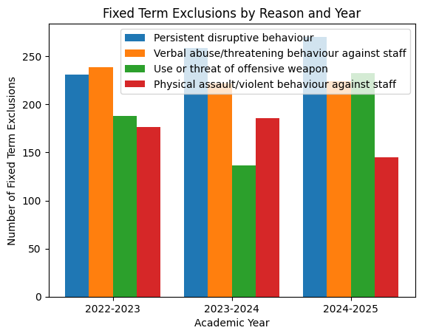
This year, our school has demonstrated a strong commitment to fostering a culture of Ready, Respectful, and Safe behaviour. We have recorded an impressive number of incidents that reflect these values, including our students showing great engagement in learning, being in the right place at the right time, and excelling in group integration. It’s wonderful to see such dedication and community spirit among our students!
While we celebrated many successes, we also faced some challenges, such as instances of refusal to follow instructions and inappropriate language. However, I am pleased to report that these were actively managed and reviewed to ensure our learning environment remains respectful and safe.
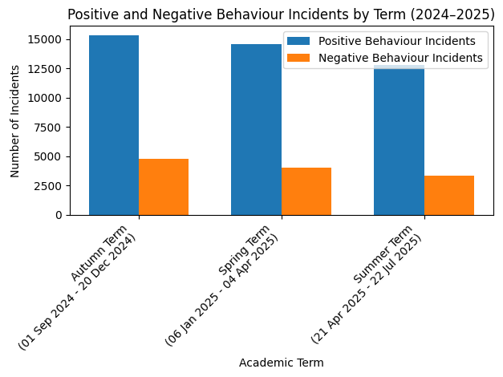
At ACE, we use CPI safety interventions grounded in trauma-informed and person-centred practice, with physical intervention always as a last resort. Staff are trained in de-escalation and both non-restrictive and restrictive strategies, and all incidents are tracked on Arbor. In 2024–2025, physical interventions involving assault on staff reduced from 88 incidents in Term 1 to 37 in Term 6 — a 58% decrease — demonstrating the positive impact of early intervention, strong relationships, and improved student self-regulation.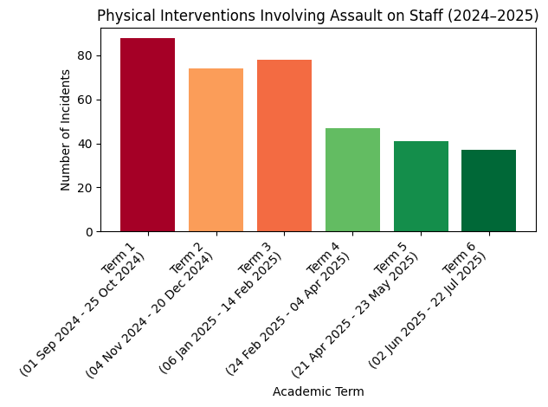
Vocational options for KS4
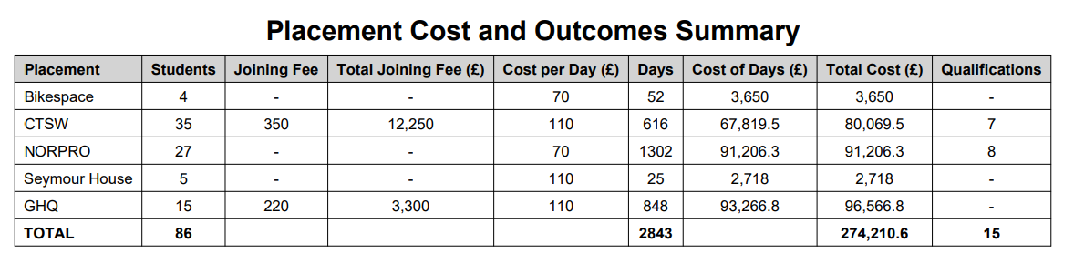 It is important to note that only a proportion of Pupil Premium funding contributed to the following placements, alongside other funding streams.
The Placement Cost and Outcomes Summary shows that across five placements, a total of 86 students were supported over 2,843 placement days, at a combined cost of £274,210.60, resulting in 15 qualifications achieved.
CTSW supported the highest number of students (35) and generated 7 qualifications, with a total cost of £80,069.50, including joining fees. NORPRO accounted for the highest number of placement days (1,302) and delivered the highest cost of days (£91,206.30), achieving 8 qualifications — the highest qualification outcome overall. GHQ incurred the largest total cost (£96,566.80) due to high placement days (848) and joining fees. Bikespace and Seymour House supported smaller numbers of students (4 and 5 respectively) with comparatively lower overall costs.
Overall, the majority of qualifications (15 in total) were achieved through CTSW and NORPRO placements, which also represent the most sustained and financially significant provisions.
A mini case study of one student has been included below to provide more detail of how ACE engages with vocational placements and to catch how successful these placements can be for our students.
Student 1- (David) In April he started at Bikespace which saw his attendance improve.
Bikespace is a not-for-profit social enterprise. Their core activity is supporting young people outside of mainstream education by providing vocational training. They offer a range of services and activities for a wide range of people in Plymouth and beyond:
- Education and training
- Recycling old bikes
- Repair services
- Second hand bike sales
- Electric bike sales
- Community bike projects
David instantly made a great impression with the staff at Bikespace due to his brilliant attitude towards his learning and his maturity around customers and other learners. His placement at Bikespace was central to his engagement in his education. Following his placement at Bikespace David took up the offer of an apprenticeship and now is working within the organisation playing a key role in their commitment to the Beryl Bike Scheme contract and the additional community projects that Bikespace has become renowned for around the city.
Reading at ACE
During the 2022/23 academic year, we identified that students were not consistently completing their termly NGRT assessments. In the Autumn term, 60 students were recorded as completing the assessment; however, only one student across ACE meaningfully engaged with it. We identified that a significant barrier was the online format of the assessment. In response, we moved to a paper-based assessment, the Salford Reading Assessment, which resulted in substantially improved engagement and more reliable reading data.
Reading data now shows an average increase of 2.6 years in reading age from baseline to Summer for students with both assessments. This significant progress reflects a sustained focus on improving reading engagement and access across the provision.
Pre-teaching key texts and structured literacy support reduced barriers to engagement and helped students approach reading tasks with greater confidence. Adjustments to assessment delivery reduced cognitive overload and encouraged greater participation in reading tasks. Structured reading workbooks provided regular, scaffolded practice, increasing engagement both in class and, in some cases, at home.
Learning Mentors have supported reading development through targeted intervention, outreach provision and supervised literacy completion in students’ homes, ensuring consistency and access for vulnerable learners. Regular staff training and moderation within the English team have strengthened consistency in reading instruction and expectations across the provision.
Collectively, these strategies have contributed to accelerated reading progress, enabling students to strengthen their ability to access the wider curriculum.
Read Write Inc. (RWI) Phonics is a structured literacy programme for children in Reception to Year 4 (ages 4–9) that teaches reading and writing through a systematic phonics-based approach. The programme begins with 20-minute daily sessions in Reception and builds to approximately one hour per day by Year 1.
At ACE, RWI is used to support and measure the impact of early reading development. However, due to the nature of our provision, assessment data can sometimes be difficult to track consistently. Students join and leave at different points throughout the year, and some require additional time to engage fully with assessment processes. This can be particularly challenging with our youngest learners. To illustrate impact more meaningfully, we have included two anonymised mini case studies demonstrating the success of the RWI programme.
Student 1 (Tim)
When Tim first joined us, he refused to read. He began on the Ditty books, the initial stage of the RWI programme. He is now working within the Grey level, the final colour band of RWI. Tim’s confidence has increased significantly, both in reading and in writing through the Get Writing books. He now reads more independently across the curriculum and shows greater confidence when encountering reading in everyday situations.
Student 2 (Hannah)
When Hannah first joined us, she was reluctant to engage in adult-led phonics activities. Following baseline assessment, she began in the Blue phonics group and gradually engaged in daily sessions. Hannah has now completed the RWI phonics programme and demonstrates significantly improved confidence in both reading and writing. She has progressed to Accelerated Reader, and her Star Reading assessment indicates a reading age of 8, which is one year above her chronological age. Her progress reflects sustained engagement and targeted phonics support.
Skillsbuilder
At ACE, we believe that Skills Builder is fundamental in developing students’ understanding of the key skills required for success at post-16 and in wider life. We are actively building a culture that strengthens students’ self-esteem, self-worth and confidence in the skills they already possess, while encouraging further development through consistent reference to the 8 Essential Skills across every base and throughout the curriculum.
The impact of Skills Builder is measured in half-termly cycles. Each half term, the whole school focuses on one Essential Skill, introduced through an assembly or dedicated lesson. Students use the Skills Builder Framework to reflect on previous progress and identify the next steps to target within PSHE, tutor time and one-to-one interventions. Skills Builder Passports are used to record and evidence progress, while Academic Leads and mentors utilise Skills Builder Hub resources to personalise support and target individual development. At the end of each half term, staff update progress on the Skills Builder Hub and share outcomes with students to reinforce growth and next steps.
Last year, ACE was awarded the Skills Builder Gold Award, recognising best practice in embedding the Skills Builder Principles across the provision. This award reflects our sustained commitment to developing essential employability and life skills alongside academic achievement.


Externally provided programmes
Programme | Provider

