
Part of the Transforming Futures Trust

Trauma Informed Behaviour Policy

Policy Information
Policy Owner | Tim Mathias
Issue Version | 1.4
Approving Committee | ACE Schools SLT and CPG
Adopted Date | June 2021
Review Cycle | Bi-Annual
Last Review Date | January 2026
Next Review Date | January 2028

Adoption of the Policy

This Policy has been adopted and reviewed by the Community Participation Group of ACE Schools, part
of Transforming Futures Trust.

Signed Lise Albert Date: 28 January 2026
(Chair of CPG)

SUMMARY OF CHANGES

Version No | Date | Summary of Changes
1 | 20.06.2022 | Minor changes
1.1 | 31.03.2023 | Appendices for Bretonside amended and Primary added
1.2 | 17.10.2023 | Minor changes to reflect management changes at Bretonside
1.2 | 27.10.2023 | CPG reviewed and approved
1.2 | 22.10.2023 | 3.2 amended MAPA to CPI-SI
1.3 | 19.02.2024 | Appendix for Bretonside behaviour amended to include vaping, controlled substance guidance and damage to property guidance
1.4 | 26/1/26 | Update to Bretonside behaviour appendix  Removal of North Hill Nurture appendix -provision no longer exists

Aims and expectations of the Policy

ACE Schools are committed to promoting and creating a positive and equitable learning environment where pupils are able to achieve in a variety of settings and educational offers. Due to the variety of provision ACE Schools offers, the varying age of pupil and their differing needs, ACE Schools looks to use a common language to support pupils through the school day. This language will be based around a Trauma Informed approach.

This Policy is to provide all staff with the necessary information to enable them to meet their responsibilities and to ensure consistent and effective practice across all school sites.

Within the Trauma Informed approach ACE Schools staff will frame conversations and expectations around 3 key words. Ready, Respectful and Safe. This is what ACE Schools expects of the pupils that attend its bases across all provisions and offers. Below is an explanation of each of the 3 key words, these will be interpreted differently at each ACE site, and you can see this in the Appendix of this policy.

- Ready – This area will focus on the pupil arriving for the start of school and each lesson on time, being in an emotional place to learn, with correct uniform and ready to engage in lessons.
- Respectful – This area focuses on the pupil’s ability to look after themself, to interact with peers and staff, being mindful of others, looking after school equipment, using their manners, and how pupils treat the school site and their interactions with the local community.
- Safe – looks at the pupil being physically, mentally and emotionally safe and looking after their school, peers and staff members. Specifically, but not exclusively looking at safe travel on school transport, walking to and from school, walking around the school site, following instructions from staff, staying in appropriate classroom/base and when out in the community.

Underpinning all communication and interactions that staff have with pupils across ACE Schools will be an understanding of the impact of trauma past and present on our pupils lives and all interactions will take a Trauma Informed approach.

A Trauma Informed Approach acknowledges evidence-based research within health and the neurosciences that demonstrate a clear correlation between the adversities a person experiences in childhood and its potentially damaging effects on their later physical health, emotional health and social outcomes.

Trauma-informed practice is not designed to treat trauma related difficulties. Instead, it seeks to address the barriers that those affected by trauma can experience when accessing the care, support and treatment they require.

2. Definition of Trauma
  - ACE School’s defines Trauma as:

“An event, series of events or set of circumstances that is experienced by an individual as physically or emotionally harmful or life threatening and that has lasting adverse effects on the individual’s functioning and mental, physical, social, emotional or spiritual well-being”.

Trauma is not the event itself.

It is what happens within you in response to an event that has been perceived as an out of control, frightening experience.

It is a subjective experience.

A normal response to an abnormal situation.

A Trauma Informed approach reconceptualizes trauma as not 'What is wrong with you?' but 'What has happened to you?

2.2 What type of events could be traumatic?
Early childhood experiences.
    - Single Incident Trauma.
    - Complex Trauma.
    - Adverse Community Environments – such as housing, family home, growing up in poverty.

3. Staff responses

3.1 Staff will use key relational approaches to communicate with ACE School’s pupils. Making sure that emotional available adults are there to support pupils where appropriate.

3.2 All staff interactions will be supported by the Protect/Relate/Regulate/Reflect model and will be supported by using the PACE approach. Play Acceptance Curiosity Empathy is a way of relating to pupils that support them to feel Safe, this can reduce the need for pupils to enter the fight mode and help reduce anxiety within schools.
- Play – Playfulness, light, open, hopeful and spontaneous.
- Acceptance – Unconditionally accepting of all of the experiences of the pupil, so the pupils will trust staff not to be judgmental.
- Curiosity – Non-judgmental active interest in how pupils experience what happens to them in their lives.
- Empathy – Felt sense of the pupil’s feelings and needs which is actively communicated to the pupils.
- Affect Attunement – Meet the pupil’s emotional intensity (positive or negative) on an energetic level, to connect with the pupil in their pain or joy. Mirroring the same level of energy to build a connection around the trauma and help the pupil understand the feelings and emotion. The pupil will hopefully see this as positive connection with staff helping to build the trusting and emotional available relationship.
- Empathy – Recognition of how the pupil is experiencing the event, even if this is very different to how you are experiencing it. Staff won’t try and persuade the pupil out of having the feeling, they will help affirm, understand and recognize what the pupil is feeling. This won’t just be empathy, but staff will find the right words/language and tone to convey the feeling of empathy.
- Containment – Staff will be able to stay thinking and feeling about the pupil’s intense feelings without deflecting into action, distraction or getting angry. At times this will mean being able to bear the pupil’s pain. Containment is also supported through clear structures to the day, boundaries and actions that are followed through on.
- Soothing (emotional regulation) – Bringing down toxic stress to tolerable stress and the moving to states of calm. Soothing and calming the pupil’s emotional dysregulated states will over time develop effective stress regulating systems in the brain and a more positive feeling through the pupil’s body. This can be done through calming conversations, timeout and sensory support/items but in each case will be bespoke to the pupil in question.
- Use of Voice and Body Language – In most cases, staff will use a calm and lowered tone of voice when managing behaviour to communicate calmness, safety and empathy to the student. Where appropriate a staff member may raise their voice. This is not in anger but with the desire to attune to and match the student’s heightened emotion before de-escalating the emotion down to gain calm. All staff ensure that their body language is always open and non-confrontational.
- De-escalation strategies – All staff are trained in a range of de-escalation strategies. These include – distraction, re-direction, change of face, use of humour, offering reflection or calming space and time. Alongside those delivered in the CPI-SI training all staff receive.
- Motional Profiling – To support all pupils, where possible, an ACE Schools assessment will be carried out so that a motional profile can be created for each pupil so key staff have an understanding of areas where they can support and what strategies they can also use to support specific pupils. These profiles will be created by staff teams working with that particular pupil and will be supported by the Pastoral Lead/Manager at their respective base.
- Rewards – Rewards will be instant where possible and will be specific to each ACE Schools base and in some cases each ACE Schools pupil. These would have been created in consultation with base staff, pupil, parents and multi-agency partner. Where possible these rewards will be instant and available to all staff to use. The list may include:

  - Phone call home by staff – Mentor, Pl, TIC, Provision Lead and SLT.
  - Golden time.
  - Raffle tickets.
  - Hot chocolate Friday.
  - Weekly reward.
  - Termly trip.
  - HT awards.
  - To be recorded on Arbor using current system.

- Consequences – ACE Schools do not believe in sanctions or punishments. Consequences for challenging behaviour will only be used with students who are at a stage emotionally where they can exercise some control or choice over their behaviour. This will focus around staff and pupils working together to look at triggers and how these can be avoided in the future and what changes can be made to support the pupil. As well as staff reflecting on their impact on the incident and how their responses can be adapted to manage future interventions. ACE Schools will also look to involve parents and carers to gain their support when looking at appropriate consequences and changes to pupil interactions
.
It is not appropriate to hold a student to account for their behaviour by implementing a consequence or sanction when they are at an emotional development stage that indicates that they are operating from the reptilian brain or brainstem during heightened emotion and revert to fight/flight or freeze at these times.

As stated before, any action agreed must be carried out to support pupil containment. These consequences will match the action of the pupil and will be considered by the team working with the child and again will be specific to each ACE Schools base and in some cases individual pupils at each ACE Schools base. Where appropriate behaviour recovery will be allowed through the outlined relational approaches and will take place for all students at a time when they are ready, able and receptive enough to think back over what has happened.

In exceptional circumstances we may need to permanently exclude a pupil for serious or persistent breaches of our policy. This will always be as a last resort as suspensions themselves are a trauma for young people. Where this may be necessary, then MAT will follow the corresponding suspensions policy.

- Example consequences
    - Phone calls home to parents / carers - Mentor, PL, TIC, Provisions lead and SLT.
    - Reparation time – apologise for behaviour, tidy area, talk through incident with emotionally available adult.
    - Incidents to be recorded on Arbor daily.

4. Searching and Scanning
  - Due to risk assessments and ACE School’s duty of care to keep students and staff safe it is necessary in some bases to ask students to hand over items as agreed in the initial ACE Schools Agreement that is signed by both parents and students. As an additional check, students may be ‘wanded’ to check for metal items such as smoking equipment etc. upon entry. In addition, staff that have been authorised by the Head Teacher, also have the power to search pupils without consent for prohibited items such as:

- Knives and weapons.
- Alcohol.
- Illegal drugs.
- Stolen items.
- Tobacco and cigarette papers.
- Fireworks.
- Any article that has been or is likely to be used to commit an offence, cause personal injury or damage to property.

5. Mobile Phones
5.1 Students will not be allowed to have their mobile phones on any ACE School base. Student mobile phones must be handed in on arrival to school. Staff will collect these and keep them in a secure area until the end of the day when they will be returned to pupils.

6. Smoking
6.1 Is not permitted on any ACE School site. All pupils must hand over smoking materials at the start of each day to staff. Staff will keep these in secure locations until the end of each school day. Any pupil found to be smoking on any ACE School site will receive a fixed period suspension for the remainder of that day.

7. Drugs
7.1 ACE Schools recognise that a range of responses may be required in the management of drug incidents. The school recognise the need to balance the welfare of the individual young person and the needs of the school. In all situations a dynamic risk assessment will be carried out to see what options can be safely taken to support the pupil. In all cases a referral will be suggested to external agencies to support the pupil and their family.

- Students under the influence of drugs – If safe to do so the pupil will be refused education due to the health and safety considerations and will be asked to return home and the parent/carer informed. If this is not safe, then where possible, the pupil will be kept safe within school until they can be collected by a parent/carer. If appropriate, ACE Schools will call an ambulance to give medical treatment to the pupil.
- Students found to have illegal drugs on them will have the drugs and any materials confiscated and these will be handed over to the Police and the issue reported to the Police and the parent/carer informed.
- Students found to be taking ILLEGAL drugs on site and or dealing drugs will be issued a suspension and the matter passed on to the Police and the parent/carer informed.

Child on child abuse
8.1 For the school procedures of dealing with allegations of child-on-child abuse please refer to the child protection and safeguarding policy section 7.8, this section also outlines how at ACE we create a supportive environment and minimise the risk of child-on-child abuse.

Appendices:

- Dover Road Behaviour Policy
- Wrap Exeter Behaviour Policy
- Bretonside Behaviour Policy
- Wrap Cornwall Behaviour Policy
- Derriford Behaviour Policy
- Plym Bridge House Behaviour Policy
- Wrap Plymouth Behaviour Policy
- Primary Behaviour Policy

ACE Schools

Appendix i - Dover Road Behaviour Policy
ACE Dover Road offers a small, nurturing environment for young people with a medical or mental health need (such as high anxiety, ASC etc.) who are unable to access mainstream education. We are a temporary provision that aims to support and enable the students to become more ready, respectful and safe and make a successful transition to mainstream or alternative placement schooling.

We work closely with other professionals to support the mental health and wellbeing of our young people and our pastoral team also provide additional intervention and support through a trauma-informed approach.

Below are some of the strategies that staff are advised to use to help our young people become more ready, respectful and safe. However, this list is not exhaustive and will always be adapted and personalised to meet the needs of every individual.

Divergent tactics
- Providing students with alternatives such as activity folders
- STORM assessments
- Lego therapy
- One-page EHCP profiles for students so that staff can easily interpret what they need to do to support students with an EHCP
- Personalised timetables
- Daily briefings and debriefs to identify any concerns or issues and to discuss possible solutions
- Identifying any triggers for individuals during admissions meetings and removing these early to prevent behaviours
- Identify changes in behaviour as early as possible to support as appropriate
- Sensory equipment to support those young people
- Regular communication with parents or carers
- Intervention from pastoral and leaders as well as referral to specialist support
- Time limited timeouts with clear instructions of where to go and return
- Personalised 5-point scales

A point system will also be used to encourage young people to demonstrate ready, respectful and safe attitudes. The points awarded will range from 1 to 4 and a £5 voucher will be awarded to students for every 100 points that they accumulate. Teachers can award students 1 point for good effort in lessons or 2 points for excellent effort. Learning mentors can award 3 points to students who have achieved well in their readiness to learn scores in a week and can also award 4 points every week. Lucky dip vouchers can also be awarded to students for exceptional work or effort by teachers or learning mentors. Lucky dip vouchers allow students to select any item from the lucky dip box.

Ready - I am ready to do my work. I am present, on time and equipped. I am wearing correct uniform. I have handed my phone in. I have a positive attitude towards learning. I am ready to learn.
Respectful - I talk to other people kindly and listen carefully. I treat others and our environment with respect and how I would like to be treated. I use respectful language in and out of school.
Safe -I keep myself and others safe. We move around the school in a safe manner. We follow instructions to keep ourselves safe. We use equipment safely and stay safe online.

ACE Schools

Appendix ii. Wrap Exeter Behaviour Policy

The students at the Wraparound provision have bespoke timetables based on their individual needs. The Ready, Respectful, Safe policy will be tailored to the individual needs of the student and a visual guide may be used to help the students understand what being Ready, Respectful, Safe means for them.
The following will be used as a guide towards overall behaviour expectations for Students at the
Exeter WRAP provision. Staff know and are aware that students may not always be able to be Ready, Respectful and Safe at all times due to their own unique learning abilities, as well as previous experiences where a trauma informed approach is to help support with these.

- Ready - I am willing and ready, I will try to be ready and attempt tasks, I will be ready to listen, and try to be emotionally ready.
- Respectful - I will think of ourselves and others, I will be kind and helpful to everybody, I will look after our school, I will follow ALL instructions from trusted adults.
- Safe -To feel okay to ask for and accept help, I will understand what safe looks like, I will listen to trusted adults.

ACE Schools

Appendix iii Bretonside Behaviour Policy

The 5 Pillars of Behaviour

Pillar 1: Trauma informed practice
As per the main policy body, staff at Bretonside are Trauma informed within their behavioural practice and draw upon a variety of techniques and strategies to secure the policy aims. Through trauma informed practice, we maintain high expectations of pupil behaviour and continually strive to raise standards to create an effective learning environment for our pupils.
When a pupil is displaying inappropriate behaviours, we recognise that each situation will be unique to the pupil and therefore the response needed will also be unique.
Rules and procedures should:
be kept to a necessary minimum;
be positively stated, telling the pupils what to do rather than what not to do;
be consistently applied and enforced;
promote the idea that every member of the school has responsibilities towards the whole.
Furthermore, we:
Encourage pupils to manage their feelings and separate feelings and actions to enable thinking to take place between the two.
Enable pupils to take responsibility for themselves and their actions in age appropriate ways;
Reflect on incidents (where behaviour choices that are against our agreed expectations) as an opportunity for learning, both for pupils involved and for staff members planning next steps.
The way we reinforce positive behaviour choices are to be based on our RRS Behaviour Policy, consistent use of RRS language and Trauma Informed Approach; Supporting pupils appropriately may require staff members to develop and employ new skills and/or strategies. Examples of which are:
- recognising the importance of and using de-escalation techniques and working as a team when managing challenging behaviours.
- using a gradual and graded response to managing challenging behaviours
- using active listening skills and participating in a process of debriefing, repair and reflection.
- We will embed the PACE (Play, Acceptance, Curiosity, Empathy) approach in order to support a pupil’s social engagement system. The development of positive pupil/staff relationships along with effective teaching which recognises individual needs encourages pupils to behave in appropriate and less challenging ways.
Staff are to use a range of strategies which allows pupils to learn how to manage their emotions more effectively without disrupting the learning of others. These strategies may include:
- Offer an alternative work to support engagement
- 5 minute movement break if appropriate
- Time alone in another part of the classroom
- Time out of class with a known adult supporting
- Learning Mentor intervention
- Use of a calm/sensory activity
- Use of time away for an agreed time
- Use of a quiet room

Staff will supervise pupils during lunch breaks, and a rota for this is in place. This establishes strong relationships between pupils and staff, providing secure attachments and key staff figures.
Consistent yet flexible implementation of this policy by all is vital, to consider the varied and complex needs of the pupils who attend our school.

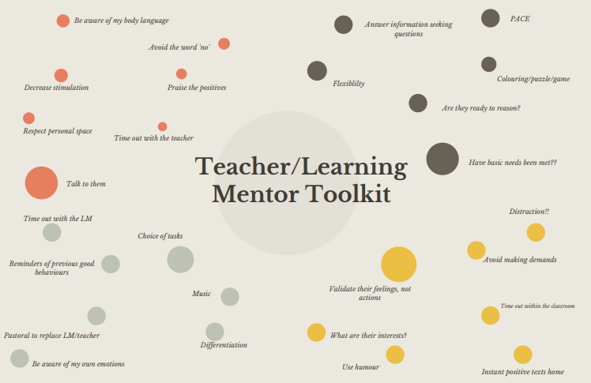
Trauma Informed Toolkit:

Pillar 2: School level behaviou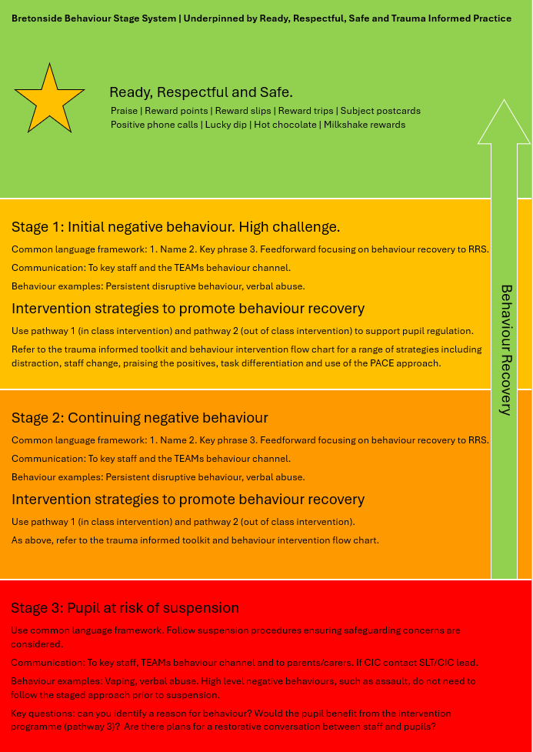r management

This section outlines a red, amber and green behaviour framework for staff. This is to be used for day-to-day school level behaviour management. This section provides information around behaviour recovery and academic intervention.
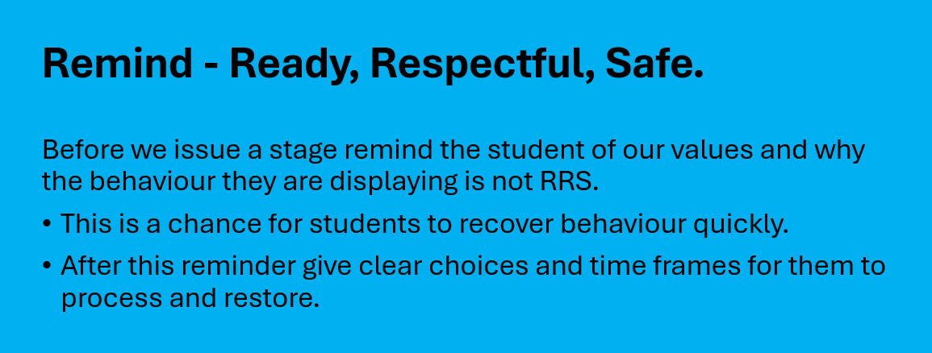
Student version: All pupils will be shown this during PEAS and reminded through regular intervention around behaviour when required.
This section has been added to clearly outline in student friendly language how the Bretonside behaviour system will be followed and how it will affect them.

Stage 1 - Warning and support
What happens:
- You’ll get a clear warning about your behaviour
- You’ll be told what needs to change and given a chance to put it right.
If you need time to calm down, you can use a regulation space or talk to a trusted adult.
What you can do:
- Take a moment to breathe and think.
- Make better choice so you can stay in class and get back on track.
Example:
“You have received a Stage 1. Let’s take a moment, what do you need to do to stay ready, respectful and safe?”
If things improve, that’s the end of it. If the behaviour continues, we move to Stage 2.

Stage 2 - Warning and support
What happens:
- A member of staff will call your parent or carer to let them know what’s happened.
- You’ll have a restorative chat with staff to talk about what went wrong and how to make it right.
- You might be offered extra support; a planned intervention with an appropriate member of staff.
What you can do:
- Be honest and take part in the reflection.
- Think about what you could do differently next time.
Example:
Let’s talk about what happened and what needs to change.. We’ll let home know so we can all support you together.”
If behaviour improves, that’s great, you’ll move forward positively.
If behaviour continues or becomes unsafe, we move to Staff 3.

Stage 3 - Suspension & Reflection
What happens:
- For serious or repeated behaviour, you will be given a suspension.
- When you return, you’ll have an Intervention to help you start fresh and plan for success.
What you can do:
- Use the time to think about what happened.
- Work with staff to make a plan and move forward safely.
Example:
“We need to take some time to make sure everyone is safe within our community.
When you come back, we’ll work together on how to make things right.”
Consistent language

Name | Key words or key phrases (Ready, Respectful, Safe) | Feedforward
Address the pupil directly (this might be difficult in large groups) | These come directly from the accepted bank of RRS key words or related phrases.  Option to use BODOR | Outline to the pupil how they can make positive changes to their behaviour or recover their behaviour.  Where poor choices of language are used staff may rephrase modelling alternatives.
Examples
Steve | You’ve climbed to the top of the fence. This is not safe. | Please climb down carefully and recover your behaviour.
Lucy | You’ve just sworn at Mrs Jones. The language you’ve used is not respectful. Verbal abuse is not welcome in our community. You are now on VA1. | If you want to move past Mrs Jones, you need to ask respectfully. In future, you could say please could I go through into G4, Mrs Jones?  You could also talk to the pupil about behaviour recovery.
Bank of key words/key phrases: Ready / Respectful / Safe / Right place / Right time / Behaviour is not welcome in our community / Behaviour recovery

Minimum behaviour expectations
- Ready: Pupils are in the right place at the right time and are sat on a chair when in the classroom

- Respectful: Pupils are respectful to staff, peers and the learning environment

- Safe: Pupils keep themselves and others safe within the learning environment

Behaviour Recovery
Behaviour Recovery at Bretonside can be defined as:
Pupils returning from unacceptable behaviour to behaviour that is ready, respectful and safe in order to re-engage in learning.
As part of the behaviour recovery process, pupils will be encouraged to accept responsibility for their behaviour and engage in restorative conversations. This may occur during the lesson or, where appropriate, after the lesson.

What does Behaviour Recovery at Bretonside look like:
In class:
Pupils return from unacceptable behaviour to behaviour that is ready, respectful and safe in order to re-engage in learning. Where appropriate, pupils should acknowledge and accept responsibility for their behaviour and engage in restorative conversations with staff and peers. This might take place within the lesson or following the lesson.
Pupil apology: this can’t always happen in the moment and can’t be demanded. Staff should acknowledge this, however they may communicate in the following way, ‘if you’re not going to apologise, then we need to see RRS/green levels of behaviour’.
Following behaviour recovery, pupils should adhere to the minimum classroom expectations.
Out of class:
Pupils who leave the classroom and display unacceptable behaviours need to demonstrate behaviour recovery (they recover to ready, respectful and safe/ green level behaviours) before they are reintegrated into the learning environment.
Whilst outside of the classroom, pupils may work with Academic Intervention staff in the behaviour recovery process. Once the pupil has displayed behaviour recovery, the aim is then re-engaging in learning.
Pupils should demonstrate ready, respectful and safe/green level behaviours to the lead member of staff before they re-enter the classroom. An accompanying member of staff may be required to enter the classroom with the pupil for a period of time.
On their return to the classroom, pupils, where appropriate, should acknowledge and accept responsibility for their behaviour/engage in restorative conversation with staff and/or peers. As previously highlighted, this may not always be possible at that exact moment in time and restorative conversations may happen after the lesson/incident. Pupils are required to adhere to the minimum classroom expectations.
Where pupils are not ready to re-engage within their lesson, they may complete tasks with another member of staff on Academic Intervention in an alternative room.

Academic Intervention
Guidance applies to AI staff and 1 to 1 staff where they are not engaged with a pupil. Academic intervention staffing timetables will be generated by the Head of Provision and displayed within the school.
If there are no pupils in corridors, staff should focus on catching pupils getting it right by awarding reward points/slips to pupils.
When there are pupils in the corridors staff should focus their efforts on interventions with pupils. The priority for intervention is the academic work for the subject they should be in. If pupils are ready to work with AI staff on academic work, work should be requested from the pupil’s lesson/subject teacher. Interventions should be completed in a separate classroom/space. If a pupil is not ready to complete academic work, TIS interventions can be completed with pupils. These need to be recorded on Arbor.
Where pupils are out of their classroom and in corridors: if there are low numbers of pupils in a group and the circumstances allow, teachers should deploy support staff to assist with pupils in corridors.
Whenever a pupil leaves a classroom, this needs to be communicated with the relevant AI staff/management/pastoral. This can be through group chat or phone call etc.
Top tips for behaviour - for staff by staff
- Model positive behaviour yourself
- Change of face
- Connection before correction
- Flexible with learning
- Find their interests
- Distraction
- “Temperature check” pupil and empathise and recognise emotions
- Worry box – child can put in their worries if they don’t verbally want to tell their tutor
- Target behaviour, not the individual.
- If they are asking you to go away, leave them alone (or ask another member of staff to take over)
- Meet and greet (Thresholding)
- Find things to relate to
- Keep emotions in check.
- Short manageable instructions with processing time
- Bring lots of energy and enthusiasm to your teaching
- Start each day as a fresh start
- Swallow your pride
- Do not prejudge
- Do not take things personally
- Have tricks up your sleeve
- Have confidence in your strengths and be able to utilise others’ strengths
- Do not be confrontational
- Offer timeout
- Different tasks
- Liaise with the learning mentor
- Do not block doors, give them space
- Positive praise to parents
- Distraction – UNO!
- Ignore to prevent behaviour developing
- Breaks (guided time away from situation)
- Planned breaks in learning that allow time to recover
- Reminders of expectations
- Praise – text home or just a quiet word in the classroom to praise them
- Reward – long term and short term as well as individual and group rewards
- Apologise to the student about the situation
- Remain calm
- High challenge, low threat
- Acknowledge anything that might be causing the child stress.
- Feed students when hungry
- Having many backups when teaching
- Show interest in the child
- Look after and respect their work
- Praise e.g. cut out part they have done
- Show the kids you’re human
- Listen to what they are saying
- Focus on any work they have completed/started
- See the positives
- Reward good behaviour, don’t respond as much to bad behaviour (unless needed) – phone calls, postcards, verbal ‘well done!’
- Be consistent, it can give confusing messages if you’re not
- Know the student, so you understand the student quirks
- Bring humour into the interactions, it helps to build relationships and at times, diffuse difficult situations
- Catch pupils getting it right. Staff on Academic intervention walk around the school giving reward points to pupils displaying positive behaviours

Pillar 3: Suspensions
This section provides guidance around suspensions (SUS).
The headteacher is the only staff member in a school able to authorise suspensions, however authority to suspend pupils has been delegated to the Senior Leadership Team. Requests for suspensions must go through the Senior Leadership Team or Head teacher.
Key definitions:
Sustained: continuing for an extended period.
Substantial: large in amount or degree.
Behaviour indicators
The indicators below outline different behaviours and include scales to guide staff decision making. Each behaviour also includes examples of amber and high level scenarios to further assist staff. The amber area within the behaviour indicators represents medium level behaviours where behaviour recovery to RRS is the focus of staff response/intervention/conversation. Once the pupil displays and/or progresses (by progressing it means they did not engage with behaviour recovery process) to the high level behaviour descriptor (indicated by the red area) they are at risk of suspension. The high level red behaviours are those we do not accept in the school community and may result in suspension or a change of provision.

Physical assault against a pupil/adult



Amber level descriptor | High level descriptor
At a lower level, the intention of a physical act may not be to cause harm (e.g. playfighting/unwanted physical contact). | An intentional physical act carried out to cause harm.
Scenario: L1 | Scenario: H1
Pupil A enters the school building following morning checks and greets their form tutor. After saying hello, Pupil A starts playfighting with them. The pupil’s intention isn’t to harm the member of staff. The playfighting is not reciprocated by the member of staff. | Following verbal abuse towards a staff member in a lesson, Pupil B punches the member of staff in the face with the intention to cause them harm.
Scenario: L2 | Scenario: H2
Pupil A begins playfighting with a new member of staff in student entrance. The staff member feels uncomfortable and does not wish to reciprocate. There is no malicious intent on the pupil’s part/intent to harm however. | Without warning pupil B approaches a member of staff and spits at them. Pupil B then purposely pushes the member of staff out of the way to gain access to a room or area causing physical injury.

Verbal abuse/threatening behaviour against a pupil or adult

Amber level descriptor | High level descriptor
At a lower-level, verbal abuse is neither sustained nor substantial. The intention is not to cause distress. | Sustained and substantial verbal abuse or threats carried out to cause distress
Scenario: L1 | Scenario: H1
Pupil A struggles with a task due to cognitive processing difficulties. Due to their frustration, they swear at a staff member who offers them support. | Pupil B is challenged by a member of staff for swearing at another pupil in the class. Pupil B then begins to verbally abuse the member of staff by swearing at them and calling them derogatory names. Following multiple attempts from staff over a period of time to support Pupil B to de-escalate and recover their behaviour, other staff receive similar abuse whilst attempting intervention. The verbal abuse is sustained by the pupil and is substantial with intent to cause distress.
Scenario: L2 | Scenario: H2
Pupil A has been winding up pupil B all day. Pupil B picks up a book and threatens to throw it at pupil A. | Following multiple opportunities for behaviour recovery, Pupil B is asked to leave the room due to verbal abuse towards staff and peers. They then go downstairs and begin verbally abusing and make significant threats to other staff members. The intent of Pupil B’s actions is to cause distress.

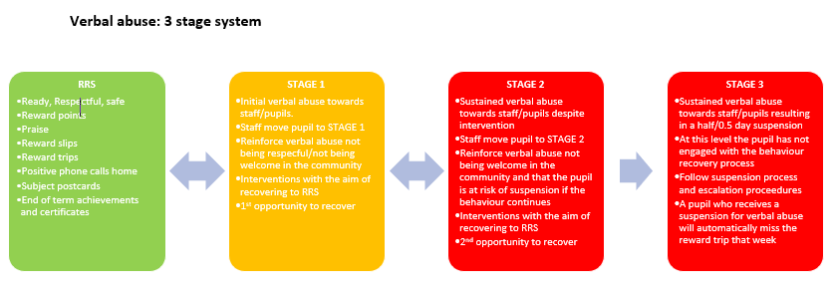
Verbal abuse definition
Threatening, abusive or insulting words towards a staff member or pupil with the intention to cause alarm, distress or harassment.
Key considerations to assist decision making
Context: In what context were the pupil’s spoken words?
Intention: What was the intention of the pupil’s spoken words?
Personal: The pupil’s words are directed at a member of staff or one of their peers.
Sustained: Consider the word sustained in terms of intervention not time. For example: despite staff attempts to engage a pupil in the behaviour recovery process through quality/meaningful intervention, the verbal abuse towards others continues and is therefore sustained. If a member of staff is unsure about the decision around a suspension this can also be supported retrospectively at the end of the day.
Behaviour recovery: Pupils return from unacceptable behaviour to behaviour that is ready, respectful and safe in order to re-engage in learning. Where appropriate, pupils should acknowledge and accept responsibility for their behaviour and engage in restorative conversations with staff and peers. This might take place within the lesson or following the lesson.
Pupil apology: This won’t always happen in the moment and can’t be demanded. Staff should acknowledge this, however they may communicate in the following way, ‘if you’re not going to apologise, then we need you to show us that you are being ready, respectful and safe’.
Learning mentors: Mentors are key to the process as they are with pupils 6 lessons a day. Mentors will be able to communicate to staff where pupils are on the verbal abuse scale. If verbal abuse occurs in the corridors staff should communicate effectively with the mentor of the pupil.
Reset: All pupils are automatically reset to RRS after lunch providing a fresh start for lesson 4.
Use or threat of an offensive weapon or prohibited item

Amber level descriptor | High level descriptor
At a lower-level, threats will be made related smoking/vaping and/or the consumption of drugs/alcohol during a pupil’s school provision. Threats related to the use of a weapon or prohibited items are neither sustained nor substantial. | At a high level a pupil will smoke or consume drugs/alcohol during school provision.  Sustained and substantial threats related to weapon use or that of a prohibited item.
Scenario: L1 | Scenario: H1
During a lesson Pupil A is asked to stop distracting another pupil and engage with the task that has been set. Pupil A swears at the member of staff and then threatens to throw a pen at them if they do not stop talking. | During the lunch break, Pupil B goes into the playground and begins to smoke/vape.
Scenario: L2 | Scenario: H2
Pupil A threatens that they have a vape in their pocket and that they are going to smoke it in the toilets. | Pupil B walks out of class, begins to vape and shares this with other pupils.

Smoking and Vaping guidance

Staff have seen that a pupil has a vape in their possession but have not seen them vaping.
Staff suspect there is a controlled substance in the vape.
Staff do not suspect that there is a controlled substance in the vape.
1. Pupil hands vape to a member of staff to recover their behaviour. The vape is stored in the pupil’s locker.

1. Pupil gives the vape to a member of staff to recover their behaviour.
The vape is confiscated, placed into a police exhibit bag, is then double bagged, and ceased by the police team who will test for controlled substances.
The incident will be logged on CPOMS and information will be provided on the police 101 email service by the pastoral team.
Parents/carers will be informed.
Additional support from multi-agencies available including: child centred policing team, youth workers, SHARP, YOT.

2. If the pupil does not give the vape to a member of staff, they will receive 0.5 day suspension*.
Parents/carers informed.
Additional support from multi-agencies available.

2. Pupil does not give the vape to a member of staff.
Pupil receives 0.5 day suspension*.
The incident will be logged on CPOMS and information will be logged on the police 101 email service by the pastoral team.
Parents/carers will be informed.
Additional support from multi-agencies available including: child centred policing team, youth workers, SHARP, YOT.

Staff suspect there is a controlled substance in the vape.
Staff do not suspect that there is a controlled substance in the vape.
Pupil has been seen vaping.

1. Pupil gives the vape to a member of staff and receives 0.5 day suspension*.
The vape is confiscated, placed into a police exhibit bag, is then double bagged, and ceased by the police team who will test for controlled substances.
The incident will be logged on CPOMS and information will be provided on the police 101 email service by the pastoral team.
Parents/carers will be informed.
Additional support from multi-agencies available including: child centred policing team, youth workers, SHARP, YOT.
1. Pupil receives 0.5 day suspension*.
Parents/carers informed.
Additional support from multi-agencies available.

2. Pupil does not give the vape to a member of staff.
Pupil receives 0.5 day suspension*.
The incident will be logged on CPOMS and information will be provided on the police 101 email service by the pastoral team.
Parents/carers will be informed.
Additional support from multi-agencies available including: child centred policing team, youth workers, SHARP, YOT.

Safeguarding considerations*
Where there are significant safeguarding concerns either before a pupil enters the school building or during their provision (for example a pupil’s presentation) we will follow the process below:
1. Ring the pupil’s parent(s)/carer(s) and request that they come to collect them due to the safeguarding concerns. If this is not possible, go to step 2.
2. If capacity allows, the pupil is dropped home by 2 members of staff. Contact should be made with parent(s)/carer(s) prior to this being actioned. If this is not possible, go to step 3.
3. If step 2 and step 3 are not possible, the pupil is required to remain in school. The pupil will be removed from the learning environment where possible and will be placed under supervision. This will apply if staff are unable to contact the pupil’s parent(s)/carer(s).
If a pupil returns home, the staff team should follow up later on in the day by contacting parents/carers.
Using 999 to contact the police
Only use 999 to contact Police if there is a situation which escalates beyond the control of staff/parents/carers and someone is in immediate danger. Intelligence should be logged on the police portal.
Pupils’ presentation
Considering a pupil’s presentation, there are a broad range of signs that they may have used a controlled substance. These include but are not limited to:

- Bloodshot eyes
- Dry mouth
- Increased appetite
- Fatigue and lethargy
- Excessive sleepiness
- Impaired balance
- Poor co-ordination
- Nausea and vomiting
- Excessive sweating
- Unconsciousness
- Numbness and tingling
- High body temperature
- Noticeable changes in personality
- Increased aggression
- May appear agitated, irritable or anxious

Medical emergency
In the event of a medical emergency, call 999 and request an ambulance.
Persistent disruptive behaviour

Amber level descriptor | High level descriptor
At a lower level, behaviour does not have a substantial or sustained impact on good order and discipline at the school. This behaviour does not have a sustained nor substantial impact upon other pupils in the learning environment. | Persistent disruptive behaviour that prejudices the maintenance of good order and discipline at the school. At a high level, persistent disruptive behaviour has a sustained and substantial impact upon other pupils in the learning environment.
Scenario: L1 | Scenario: H1
During a lesson, Pupil A begins to talk over the teacher and starts shouting out random words. Following challenge from the teacher, the pupil’s behaviour stops. | During a lesson, Pupil B begins to throw pens around the room. They then begin to throw books, chairs, tables and to destroy the room. Due to this behaviour the lesson stops and the other pupils are unable to continue with the task. Pupil B refuses to engage with staff despite providing multiple opportunities for behaviour recovery and intervention. This behaviour has had a substantial impact on the learning environment and has negatively impacted on pupils’ progress.
Scenario: L2 | Scenario: H2
Pupil B interrupts a teacher’s instructions numerous times at the start of the lesson. Following intervention, this behaviour stops. | Pupil B is running around corridors persistently (over a series of lessons). Intervention has been offered from multiple sources (pastoral, learning mentor etc.) however the pupil has refused to engage. This has an adverse effect on the behaviour and learning of others. Persistent amber behaviours are displayed such as targeted verbal abuse, unsafe behaviour, climbing and kicking doors.

Spitting

Amber level descriptor | High level descriptor
At a lower level, threats of spitting at either someone, or something are made. | A pupil spits at someone during their school provision.
Scenario: L1 | Scenario: H1
Pupil A leaves their lesson after refusing to complete the task set by the teacher. Whilst in the corridor they are approached by another member of staff. Pupil A threatens to spit at the member of staff unless they leave them alone. | Following Pupil B verbally abusing a member of staff, they spit at them.
Scenario: L2 | Scenario: H2
Pupil A threatens to spit at another pupil following an argument. | Pupil B walks up to a member of staff and spits at them without warning.

Damage

Amber level descriptor | High level descriptor
At a lower level, the intention of a pupil’s actions is not to cause damage to property. | A pupil who without lawful excuse causes substantial damage to property.
Scenario: L1 | Scenario: H1
During a lesson pupil A begins to play with a plastic ruler. They start to flick the ruler at their desk. Following this, the ruler breaks. It was not the pupil’s intention to break the ruler. This was accidental damage. | Following the lunch break, Pupil B attempts to gain access to a classroom where a group are in a tutor time session. Pupil B tries the door however is unable to get in. They then intentionally kick the door aggressively causing the glass to smash.
Scenario: L2 | Scenario: H2
Pupil B, out of frustration, kicks a ball and it smashes a water bottle. Pupil B is shocked as it was not their intention to cause damage. | Pupils B aggressively snatches a teacher’s glasses and throws them to the floor. They then deliberately stamp on them causing damage.

Damage guidance
Depending on the severity of the damage caused, staff may decide that a pupil goes directly to stage 2.
Stage 1: Following a pupil’s first instance of damage to property, the school will put in place internal consequences. These include the use of suspension, sending a bill for the damage to parents/carers and pupils repairing damage and cleaning graffiti.
Stage 2: Following a pupil’s second instance of damage to property, alongside internal consequences, the school will liaise with the police team about the possibility of external intervention for example, the use of the IMPACT programme.
Stage 3: Following a pupil’s third instance of damage to property, alongside internal consequences, the school will report the incident to the police’s 101 service.

Pillar 4: Strategic decision making
Strategic decision making is designed to be both proactive and reactive. Through engagement with Arbor, trends and patterns of behaviour can be identified. Using this data, informed strategic decisions can be made about short, medium and long term pupil behaviour. Through identifying key patterns and trends, ‘behaviour focus blocks’ can be designed and implemented with the aim of positively improving behaviour.
The strategic decision making process is outlined below:
- Behaviour data input on Arbor by base staff
- Key staff analyse data and identify behavioural trends and patterns
- Behaviour focus blocks are planned to target trends and patterns
- Staff briefed on behaviour focus block (including timescale)
- Parent(s)/carer(s) are informed about upcoming focus blocks via formal school communication
- Behaviour focus block begins for the base
- Analyse and review behaviour data and focus block impact. Gain staff voice
- Adapt and implement behaviour focus blocks throughout the year as guided by data

Whilst one block may come to a conclusion and another starts, that doesn’t mean that our standards and expectations are reduced in relation to the previous aspect of behaviour. Blocks are designed to be built upon, and whilst the focus may change, our standards and expectations of those previous do not.

Pillar 5: Accountability
As members of staff, we have a duty to support each other and our pupils.
Everyone has a role and responsibility in maintaining high expectations and standards of behaviour.
Accountability is multidirectional.
There must be equity and transparency in decision making processes.

ACE Schools
Part of the Transforming Futures Trust

Appendix iv. Wrap Cornwall Behaviour Policy
The students attending the Wraparound provision at Camborne, St. Austell and Launceston have bespoke timetables based on their individual needs. The Ready, Respectful, Safe policy will be tailored to the individual needs of the student and a visual guide will be used to help the students understand what being Ready, Respectful, Safe means for them. Students will have the opportunity to explore and develop the use of a common language to become better engaged with behavioural expectations. This will be achieved through a range of Pupil Voice activities across the week.
The following will be used as a guide for overall behaviour expectations for students at the
Wraparound provision. Staff have an awareness that students may not always be able to be Ready, Respectful and Safe at all times due to their previous experiences and will use trauma informed strategies to help to support them with this.

Ready - I am present, on time and equipped. I have a positive attitude towards learning. I am ready to learn.

Respectful - I talk kindly and listen carefully. I treat others and our environment with respect and how I would like to be treated.

- Safe - We move around the school in a safe manner, we follow instructions to keep ourselves safe, we use equipment safely and we stay safe online.

ACE Schools
Part of the Transforming Futures Trust

Appendix v. Derriford Behaviour Policy

A Ready
- Awake and dressed appropriately
- Medically able to engage in education
- Eaten breakfast and had a drink (if applicable/able)
- Focused and willing to learn
- School work, including logins, available and to hand
- Ready for us to be in your environment
- Prepared for engagement

B Respectful
- Take pride in your work
- Ready for the session
- Ready to listen and give eye contact where you can
- Using appropriate language
- Value others’ opinions, even if you disagree
- Appropriate learning behaviour

C Safe
- Follow instructions and ask questions
- Tell/indicate to an adult if you feel unwell/not your normal
- Respect your own safety with equipment – is what you have appropriate?
- Hand equipment back if you feel unsafe
- Use the internet appropriately and on task
- Take medication and attend appointments
- Tidy equipment away

ACE Schools
Part of the Transforming Futures Trust

Appendix vi - Plym Bridge House Behaviour Policy

A Ready
- Awake and out of bed
- Done personal hygiene
- Eaten breakfast and had a drink
- Taken Medication
- Able to engage with staff
- School work available and to hand
- Ready for us to be in your environment

B Respectful
- Take pride in your work
- Ready to listen and give eye contact where you can
- Using appropriate language
- Value others’ opinions, even if you disagree
- Appropriate learning behaviour

C Safe
- Follow instructions and ask questions
- Tell/indicate to an adult if you don’t feel OK
- Respect your own safety with equipment – is what you have appropriate?
- Hand equipment back if you feel unsafe
- Use the internet appropriately and on task
- Tidy equipment away

ACE School
Part of the Transforming Futures Trust

Appendix vii - Wrap Plymouth Behaviour Policy
The students at the Wraparound provision have bespoke timetables based on their individual needs. The Ready, Respectful, Safe policy will be tailored to the individual needs of the student and a visual guide may be used to help the students understand what being Ready, Respectful, Safe means for them.

The following will be used as a guide for overall behaviour expectations for students at the Wraparound provision. Staff have an awareness that students may not always be able to be Ready, Respectful and Safe at all times due to their previous experiences and will use trauma informed strategies to help to support them with this.

Ready - I am present, on time and equipped. I have a positive attitude towards learning. I am ready to learn.

Respectful -I talk kindly and listen carefully. I treat others and our environment with respect and how I would like to be treated.

Safe - We move around the school in a safe manner, we follow instructions to keep ourselves safe, we use equipment safely and we stay safe online.

ACE Schools
Part of the Transforming Futures Trust

Appendix iiv. Primary Behaviour Policy
The students at the primary provision have bespoken timetables based on their individual needs. The Ready, Respectful, Safe policy will be tailored to the individual needs of the student and a visual guide may be used to help the students understand what being Ready, Respectful, Safe means for them. Visual timetables and reward charts are used.
The following will be used as a guide for overall behaviour expectations for students at the primary provision. Staff have an awareness that students may not always be able to be Ready, Respectful and Safe at all times due to their previous experiences and will use trauma informed strategies to help to support them with this.

A Ready - I am present, on time and equipped. I have a positive attitude towards learning. I am ready to learn.

B Respectful - I talk kindly and listen carefully. I treat others and our environment with respect and how I would like to be treated. “Kind hands, Kind feet, Kind words”

C Safe - We move around the school and off site in a safe manner, we follow instructions to keep ourselves safe, we use equipment safely, and we stay safe online.

