

Exams Policy

Policy Information
Policy Owner | Exams Officer
Issue Version | 5.0
Approving Committee | ACE Schools LGB / Education and Safeguarding Committee
Adopted Date | June 2021
Review Cycle | Annual
Last Review Date | March 2026
Next Review Date | March 2027

Adoption of the Policy

This Policy has been adopted and reviewed by the Trustees of Transforming Futures Trust

Signed: L.Albert Date: 28/4/26

Chair of the Education and Safeguarding Committee

1

Version Control Amendments

Version No | Date | Summary of Changes
2.0 | Feb 2023 | Compliance with JCQ
3.0 | Jan 2024 | Updates to key staff names and roles; JCQ publication references; key dates.  Complaints section amended to separate from internal appeals; Complaints form added and Internal Appeals from amended.  Section 13 added to provide reference to new centre Malpractice policy, meeting statutory requirement#  Section 14 added to meet requirements for Conflict of Interest policy.
4.0 | March 2025 | Addition of resilience arrangements.
5.0 | March 2026 | Updates to dates and references  Internal appeals procedure update to include AI section  Data protection – informing candidates of information held expanded

Contents
1. Key staff involved in the Exams Policy 4
2. Purpose of the Exams Policy 4
3 Resilience arrangements (GR 3.16-19) 5
Process for gathering evidence of candidate assessment performance 5
4. Contingency planning and escalation process 5
5. Management of non-examination assessments 5
6. Internal appeals procedure 6
7. Post results services procedures 15
8. Candidate Identification Procedure 17
9. Emergency Evacuation of Exams 17
10. Word processors for Exams 19
11. Data Protection for Exams 24
12. Complaints Procedure 27
13. Whistleblowing 30
14. Malpractice 33
15. Conflict of interest 33
Appendix 1 – Exam Accounts guide 36
Appendix 2 – Emergency evacuation procedures 43
Appendix 3 - Internal Appeals form 44
Appendix 5 - Complaints and Appeals log 46

1. Key staff involved in the Exams Policy
Role | Name(s)
Head of centre | Ruth Westwood
Exams officer line  manager (Senior leader) | Tim Mathias
SENCo | Rachel Crozier
Exams Officer | Vickie Keast
Exams Assistants | Gemma Ritchie (Bretonside 54424)  Kieran Murrant (Redruth 53849)  Darren McDonald-Free (Bodmin 53645)
Key holders | Bretonside 54424 | Bodmin 53645 | Redruth 53849
Key holders | Tim Mathias  Vickie Keast  Mary Tapscott-Nott  Kay McCarthy  Gemma Ritchie  Julie Root | Vickie Keast  Becky Smith  Pippa Counter  Darren McDonald-Free  Matthew Read  Natasha Curtis | Vickie Keast  Kieran Murrant  Lisa Baxter  Vicky Moon  Matthew Read
Head of Department | Melissa Legg – English  Helen Cummings – Maths  Claire Miller – Science  Sarah Bird – DT & Art  Laura Kirk-Potter – PSHE  Steve Sampson – Humanities  Chris Harris – PE

2. Purpose of the Exams Policy
Ace Schools is committed to ensuring that the exams management and administration process is run effectively and efficiently and in compliance with the published JCQ regulations and awarding body requirements.
This exam policy will ensure that

- the workforce is well informed and supported
- all centre staff involved in the exams process clearly understand their roles and responsibilities
- all exams and assessments are conducted according to JCQ and awarding body regulations, guidance and instructions, thus maintaining the integrity and security of the exam/assessment system at all times
- exam candidates understand the exams process and what is expected of them
This policy is reviewed annually to ensure ways of working in the centre are accurately reflected and that exams and assessments are conducted to current JCQ (and awarding body) regulations, instructions and guidance.
This policy will be communicated to all relevant centre staff. It will be easily accessible via SharePoint hub.

3 Resilience arrangements (GR 3.16-19)
The centre must ensure they are familiar with the regulators’ guidance on ensuring resilience in the qualifications system. Ace Schools has in place a process for gathering evidence of candidate performance in line with the published guidance from DfE.
In the unlikely event that the government determines that examinations cannot go ahead, the centre will need evidence of candidate assessment performance, such as mock examinations, to enable alternative methods of awarding grades.

Process for gathering evidence of candidate assessment performance
Ace Schools hold mock exams in Nov/Dec and a secure round of mock exams is held in March. All March mock exams are based on semi-secure papers from the previous summer series and mocks are conducted in full exam conditions. All candidates sit as the same time with a consistent timetable applied to all exam sites within Ace Schools.
Completed mock exams are marked using exam board mark schemes. Photocopies can be made for candidates for learning and revision purposes but original mock papers are stored securely by the Head of each department until at least the end of the relevant summer exam series.
Guidance on collecting evidence of student performance to ensure resilience in the qualifications system - GOV.UK (www.gov.uk)

4. Contingency planning and escalation process
See additional document Exam Contingency Plan and Escalation Process 2025-2026.

5. Management of non-examination assessments
See additional Non-Exam Assessment Policy 2025-2026.

6. Internal appeals procedure
Purpose of the procedure
This procedure confirms Ace Schools compliance with JCQ’s General Regulations for Approved Centres (section 5.3z, 5.8) that the centre will:
- have in place for inspection that must be reviewed and updated annually by a member of the senior leadership team and communicated within the centre, an internal appeals procedure which must cover at least appeals regarding internal assessment decisions, access to post-result services and appeals, and centre decisions relating to access arrangements and special consideration
- draw to the attention of candidates and their parents/carers their internal appeals procedure
This procedure covers appeals relating to:
- Internal assessment decisions (centre assessed marks)
- Centre decisions not to support an application for clerical re-check, a review of marking, a review of moderation or an appeal
- Centre decisions relating to access arrangements and special consideration
- Centre decisions relating to other administrative issues

Appeals relating to internal assessment decisions (centre assessed marks)

Certain qualifications contain components/units of non-examination assessment, controlled assessment and/or coursework which are internally assessed (marked) by Ace Schools and internally standardised. The marks awarded (the internal assessment decisions) which contribute to the final grade of the qualification are then submitted by the deadline set by the awarding body for external moderation.
The qualifications delivered at Ace School containing internally assessed components/units are:

Awarding body | Qualification level & title | Qualification code
AQA | GCSE: English Language | 8700
AQA | Entry Level Certificate: Science | 5961
AQA | Entry Level Certificate: Step Up to English | 5972 / 5973
WJEC | GCSE: Physical education (short course) | C555QT
Pearson | Entry level certificate: Maths | NMA0
Pearson | BTEC Award in Home Cooking Skills | HXGS9
OCR | Entry level certificate: Computer Science | R354A
OCR | Entry level certificate: Geography | R407A
OCR | Entry level certificate: History | R435A
OCR | Entry level certificate: Physical education | R463C
WJEC | Entry level pathways | Various

This procedure confirms Ace Schools compliance with JCQ’s General Regulations for Approved Centres (section 5.7) that the centre will:
- have in place and be available for inspection purposes, a written internal appeals procedure relating to internal assessment decisions and to ensure that details of this procedure are communicated, made widely available and accessible to all candidates
- before submitting marks to the awarding body inform candidates of their centre assessed marks and allow a candidate to request a review of the centre’s marking

Marks to candidates | AO submission date | Qualification | Details | Exam series
12/04/2026 | 15/05/2026 | GCSE | Final date for submission of centre assessed marks (AQA, OCR, Pearson and WJEC) | Summer-2026
12/04/2026 | 15/05/2026 | ELC | Final date for submission of centre assessed marks (AQA, OCR, Pearson and WJEC) | Summer-2026
TBC | TBC | BTEC | Final date for submission of centre assessed marks BTEC | Summer-2026

Ace Schools is committed to ensuring that whenever its staff mark candidates’ work this is done fairly, consistently and in accordance with the awarding body’s specification and subject-specific associated documents.
Ace Schools ensures that all centre staff follow a robust policy regarding the management of GCE and GCSE non-examination assessments including controlled assessments and coursework. This policy details all procedures relating to non-examination assessments for GCSE, Functional Skills, Entry Level Certificates and Entry Level Pathways, including the marking and quality assurance/internal standardisation processes which relevant teaching staff are required to follow.
Candidates’ work will be marked by staff who have appropriate knowledge, understanding and skill, and who have been trained in this activity and do not have any potential conflicts of interest. If AI tools have been used to assist in the marking of candidates’ work, they will not be the sole marker. Ace Schools is committed to ensuring that work produced by candidates is authenticated in line with the requirements of the awarding body. Where more than one subject teacher/tutor is involved in marking candidates’ work, internal moderation and standardisation will ensure consistency of marking.
On being informed of their centre assessed marks, if a candidate believes that the above procedures were not followed in relation to the marking of their work, or that the assessor has not properly applied the marking standards to the marking, then the candidate may make use of the appeals procedure below to consider whether to request a review of the centre’s marking.

Ace Schools will
- ensure that candidates are informed of their centre assessed marks so that they may request a review of the centre’s marking before marks are submitted to the awarding body

- inform candidates that they will need to explain on what grounds they wish to request a review of an internally assessed mark as a review will only focus on the quality of work submitted

- inform candidates that they may request copies of materials (as a minimum, a copy of the marked assessment material (work) and the mark scheme or assessment criteria plus additional materials which may vary from subject to subject) to assist them in considering whether to request a review of the centre’s marking of the assessment

- having received a request for copies of materials, promptly make them available to the candidate within 5 working days. This will either be the originals viewed under supervised conditions or copies.

- inform candidates they will not be allowed access to original assessment material including artefacts, unless supervised

- provide candidates with five working days, to allow them to review copies of materials and reach a decision.

- provide a clear deadline for candidates to submit a request for a review of the centre’s marking. Requests will not be accepted after this deadline. Requests must be made in writing within 5 working days of receiving copies of the requested materials by completing the internal appeals form and candidates must explain on what grounds they wish to request a review. These should be submitted to the Exams Office by post or email (ACE_Exams@tranformingfutures.org.uk)

- allow 5 working days for the review to be carried out, to make any necessary changes to marks and to inform the candidate of the outcome, all before the awarding body’s deadline for the submission of marks

- ensure that the review of marking is conducted by an assessor who has appropriate competence, has had no previous involvement in the assessment of that candidate for the component in question and has no personal interest in the outcome of the review

- instruct the reviewer to ensure that the candidate’s mark is consistent with the standard set by the centre

- inform the candidate in writing of the outcome of the review of the centre’s marking

The outcome of the review of the centre’s marking will be made known to the head of centre who will have the final decision if there is any disagreement on the mark to be submitted to the awarding body. A written record of the review will be kept and made available to the awarding body upon request.
The awarding body will be informed if the centre does not accept the outcome of a review.
The moderation process carried out by the awarding body may result in a mark change, either upwards or downwards, even after an internal review. The internal review process is in place to ensure consistency of marking within the centre, whereas moderation by the awarding body ensures that centre marking is in line with national standards. The mark submitted to the awarding body is subject to change and should therefore be considered provisional.
Appeals against decisions to reject a candidate’s work on the grounds of malpractice

The JCQ Information for candidates documents (Coursework, Non-examination assessments, Social media) which are distributed to all candidates prior to relevant assessments taking place, inform candidates of the things they must and must not do when they are completing their work.
The JCQ Information for candidates - AI (Artificial Intelligence and assessments) or similar centre document is issued to candidates prior to assessments taking place (and prior to a candidate signing the declaration of authentication which relates to their work).
Ace Schools ensures that staff delivering/assessing coursework, internal assessments and/or non-examination assessments are aware of centre procedures relating to the authentication of learner work and have robust processes in place for identifying and reporting plagiarism (including AI misuse) and other potential candidate malpractice.
Candidate malpractice offences relating to the content of work (i.e. inappropriate/offensive content, copying/collusion, plagiarism (including AI misuse) and/or false declaration of authentication) which are discovered in a controlled assessment, coursework or non-examination assessment component prior to the candidate signing the declaration of authentication do not need to be reported to the awarding body but will be dealt with in accordance with the centre’s internal procedures.
Malpractice by a candidate discovered in a controlled assessment, coursework or non-examination assessment where the offence does not relate to the content of candidates’ work (e.g. possession of unauthorised materials, breach of assessment conditions) or where a candidate has signed the declaration of authentication, must be reported to the awarding body.
If there are doubts about the authenticity of the work of a candidate or irregularities are identified in a candidate’s work before the candidate has signed the declaration of authentication/authentication statement (where required) and malpractice is suspected, Ace Schools will:
· follow the authentication procedures and/or malpractice instructions in the relevant JCQ document (Instructions for conducting non-examination assessments/Instructions for conducting coursework) and any supplementary guidance that may be provided by the awarding body. Where this may lead to the decision to not accept the candidate’s work for assessment or to reject a candidate’s coursework on the grounds of malpractice, the affected candidate will be informed of the decision.
If a candidate who is the subject of the decision disagrees with the decision:
· a written request, setting out as clearly and concisely as possible the grounds for the appeal including any further evidence relevant to supporting the appeal, should be submitted
· an internal appeals form should be completed and submitted within 5 working days of the decision being made know to the appellant
The appellant will be informed of the outcome of the appeal [(insert when within 5 working days of the appeal being received and logged by the centre.
This procedure is informed by the JCQ documents Instructions for conducting non-examination assessments (4.6, 6.1, 9), Instructions for conducting coursework (6, 7, 13.5), Review of marking (centre assessed marks) suggested template for centres, Notice to Centres - Informing candidates of their centre assessed marks and Suspected Malpractice: Policies and Procedures (3.3, 4.5 including reference to Form JCQ/M1)

Appeals relating to decisions the centre’s decision not to support an application for a clerical re-check, a review of marking, a review of moderation or an appeal
This procedure confirms Ace Schools compliance with JCQ’s General Regulations for Approved Centres 2022-2023 (section 5.13) that the centre will:
have available for inspection purposes and draw to the attention of candidates and their parents/carers, a written internal appeals procedure to manage disputes when a candidate disagrees with a centre decision not to support an application for a clerical re-check, a review of marking, a review of moderation or an appeal
Following the issue of results, awarding bodies make post-results services available. Full details of these services, internal deadlines for requesting a service and fees charged are provided by the exams officer.
Candidates are also made aware of the arrangements for post-results services prior to the issue of results. Candidates are also informed of the periods during which senior members of centre staff will be available/accessible immediately after the publication of results so that results may be discussed, and decisions made on the submission of reviews of marking. This information is provided to candidates in writing along with their invitation to collect results. This is distributed to candidates directly by base staff.
If the centre or a candidate (or their parent/carer) has a concern and believes a result may not be accurate, post-results services may be considered.
The JCQ post-results services currently available are detailed below.
Reviews of Results (RoRs):
- Service 1 (Clerical re-check)
This is the only service that can be requested for objective tests (multiple choice tests)
- Service 2 (Review of marking)
- Priority Service 2 (Review of marking)
This service is available for externally assessed components of both unitised and linear GCE A-level specifications
- Service 3 (Review of moderation)
This service is not available to an individual candidate
Access to Scripts (ATS):
- Copies of scripts to support reviews of marking
- Copies of scripts to support teaching and learning

Where a concern is expressed that a particular result may not be accurate, the centre will look at the marks awarded for each component part of the qualification alongside any mark schemes, relevant result reports, grade boundary information etc. when made available by the awarding body to determine if the centre supports any concerns.
For written components that contributed to the final result, the centre will:
- Where a place a university or college is at risk, consider supporting a request for a Priority Service 2 review of marking
- In all other instances, consider accessing the script by:
  - (where the service is made available by the awarding body) requesting a priority copy of the candidate’s script to support a review of marking by the awarding body deadline or
  - (where the option is made available by the awarding body) viewing the candidate’s marked script online to consider if requesting a review of marking is appropriate
- Collect informed written consent/permission from the candidate to access their script
- On access to the script, Heads of Department will consider if it is felt that the agreed mark scheme has been applied correctly in the original marking and if the centre considers there are any errors in the marking
- Support a request for the appropriate RoR service (clerical re-check or review of marking) if any error is identified
- Collect informed written consent from the candidate to request the RoR service before the request is submitted
- Where relevant, advise an affected candidate to inform any third party (such as a university or college) that a review of marking has been submitted to an awarding body
Written candidate consent (informed consent via candidate email or Microsoft forms is acceptable) is required in all cases before a request for a RoR service 1 or 2 (including priority service 2) is submitted to the awarding body. Consent is required to confirm the candidate understands that the final subject grade and/or mark awarded following a clerical re-check or a review of marking, and any subsequent appeal, may be lower than, higher than, or the same as the result which was originally awarded. Candidate consent must only be collected after the publication of results.
For any moderated components that contributed to the final result, the centre will:
- Confirm that a review of moderation cannot be undertaken on the work of an individual candidate or the work of candidates not in the original sample submitted for moderation
- Consult the moderator’s report/feedback to identify any issues raised
- Determine if the centre’s internally assessed marks have been accepted without change by the awarding body – if this is the case, a RoR service 3 (Review of moderation) will not be available
- Determine if there are any grounds to submit a request for a review of moderation for the work of all candidates in the original sample
Where a candidate disagrees with a centre decision not to support a clerical re-check, a review of marking or a review of moderation, the centre will:
- For a review of marking (RoR service 1 or 2), first advise the candidate to access a copy of their script to support a review of marking by providing written permission for the centre to access the script (and any required fee for this service) for the centre to submit this request
- After accessing the script to consider the marking, inform the candidate that if a request for a review of marking (RoR service 1 or 2) is required, this must be submitted by the deadline set by the centre by providing informed written consent (and the required fee for this service) for the centre to submit this request
- Inform the candidate that a review of moderation (RoR service 3) cannot be requested for the work of an individual candidate or the work of a candidate not in the original sample
If the candidate (or their parent/carer) believes there are grounds to appeal against the centre’s decision not to support a review of results, an internal appeal can be submitted to the centre by completing the internal appeals form at least 5 working days prior to the internal deadline for submitting a request for a review of results.
The appellant will be informed of the outcome of their appeal before the internal deadline for submitting a RoR.

Following the RoR outcome, an external appeals process is available if the head of centre remains dissatisfied with the outcome and believes there are grounds for appeal. The JCQ publications Post-Results Services and
JCQ Appeals Booklet (A guide to the awarding bodies’ appeals processes) will be consulted to determine the acceptable grounds for a preliminary appeal.
Where the head of centre is satisfied after receiving the RoR outcome, but the candidate (or their parent/carer) believes there are grounds for a preliminary appeal to the awarding body, a further internal appeal may be made to the head of centre. Following this, the head of centre’s decision as to whether to proceed with a preliminary appeal will be based upon the acceptable grounds as detailed in the JCQ Appeals Booklet. Candidates or parents/carers are not permitted to make direct representations to an awarding body.
The internal appeals form should be completed and submitted to the centre within 5 working days of the notification of the outcome of the RoR. Subject to the head of centre’s decision, this will allow the centre to process the preliminary appeal and submit to the awarding body within the required 30 calendar days of receiving the outcome of the review of results process. Awarding body fees which may be charged for the preliminary appeal must be paid to the centre by the appellant before the preliminary appeal is submitted to the awarding body (fees are available from the exams officer). If the appeal is upheld by the awarding body, this fee will be refunded by the awarding body and repaid to the appellant by the centre.

Appeals regarding centre decisions relating to access arrangements and special consideration
This procedure confirms Ace Schools compliance with JCQ’s General Regulations for Approved Centres (section 5.3z) that the centre will:
- have in place and available for inspection a written internal appeals procedure which must cover at least appeals regarding... centre decisions relating to access arrangements and special consideration
Ace Schools will:
- comply with the principles and regulations governing access arrangements and special consideration as set out in the JCQ publications Access Arrangements and Reasonable Adjustments and A guide to the special consideration process
- ensure that all staff who manage and implement access arrangements and special consideration are aware of the requirements and are appropriately supported and resourced
Access arrangements and reasonable adjustments

In accordance with the regulations, Ace Schools:
- recognises its duty to explore and provide access to suitable courses, submit applications for reasonable adjustments through the access arrangements process and make reasonable adjustments to the services the centre provides to disabled candidates.
- complies with its responsibilities in identifying, determining and implementing appropriate access arrangements and reasonable adjustments
Failure to comply with the regulations have the potential to constitute malpractice which may impact on a candidate’s result(s).
Examples of failure to comply include:
- putting in place access arrangements/adjustments that are not approved
- failing to consider putting in place access arrangements (which may be a failure to comply with the duty to make reasonable adjustments)
- permitting access arrangements/adjustments within the centre which are not supported by appropriate evidence
- charging a fee for providing reasonable adjustments to disabled candidates
Special consideration
Where Ace Schools has appropriate evidence authorised by a member of the senior leadership team to support an application, it will apply for special consideration at the time of the assessment for a candidate who is affected by adverse circumstances beyond their control when the issue or event has had, or is reasonably likely to have had, a material effect on the candidate’s ability to take an assessment or demonstrate their normal level of attainment in an assessment.
Centre decisions relating to access arrangements, reasonable adjustments and special consideration
This may include Ace Schools decision not to make/apply for a specific reasonable adjustment or to apply for special consideration, in circumstances where a candidate does not meet the criteria for, or there is no evidence/insufficient evidence to support the implementation of an access arrangement/reasonable adjustment or the application of special consideration.
Where Ace Schools makes a decision in relation to the access arrangement(s), reasonable adjustment(s) or special consideration that apply for a candidate or candidates:
- If a candidate who is the subject of the relevant decision (or the candidate’s parent/carer) disagrees with the decision made and reasonably believes that the centre has not complied with its responsibilities or followed due procedures, a written request setting out the grounds for appeal should be submitted
- An internal appeals form should be completed and submitted within 5 working days of the decision being made known to the appellant.
To determine the outcome of the appeal, the head of centre/SLT lead for exams will consult the respective JCQ publication to confirm the centre has complied with the principles and regulations governing access arrangements and/or special consideration and followed due procedures.
The appellant will be informed of the outcome of the appeal within 5 working days of the appeal being received and logged by the centre.
If the appeal is upheld, Ace Schools will proceed to implement the necessary arrangements/submit the necessary application.

This procedure is informed by the JCQ publications A guide to the awarding bodies’ appeals processes (chapter 3), Suspected Malpractice: Policies and Procedures (section 3.3), General Regulations for Approved Centres (section 5.4), Access Arrangements and Reasonable Adjustments (Importance of these regulations) and A guide to the special consideration process (sections 1, 2, 6)

Appeals regarding centre decisions relating to other administrative issues
Circumstances may arise that cause Ace Schools to make decisions on administrative issues that may affect a candidate’s examinations/assessments.
Where Ace Schools may make a decision that affects a candidate or candidates:
- If a candidate who is the subject of the relevant decision (or the candidate’s parent/carer) disagrees with the decision made and reasonably believes that the centre has not complied with the regulations or followed due process, a written request setting out the grounds for appeal should be submitted
- An internal appeals form should be completed and submitted within 5 working days of the decision being made known to the appellant.
The appellant will be informed of the outcome of the appeal within 5 working days of the appeal being received and logged by the centre.

This procedure is informed by the JCQ publication A guide to the awarding bodies’ appeals processes (chapter 7)

Further guidance to inform and implement appeals

JCQ publications
- General Regulations for Approved Centres
https://www.jcq.org.uk/exams-office/general-regulations
- Post-Results Services
https://www.jcq.org.uk/exams-office/post-results-services
- JCQ Appeals Booklet (A guide to the awarding bodies’ appeals processes)
https://www.jcq.org.uk/exams-office/appeals
- Notice to Centres – Informing candidates of their centre assessed marks https://www.jcq.org.uk/exams-office/non-examination-assessments
- Suspected Malpractice: Policies and Procedures https://www.jcq.org.uk/exams-office/malpractice/
- Access Arrangements and Reasonable Adjustments https://www.jcq.org.uk/exams-office/access-arrangements-and-special-consideration/regulations-and-guidance/
- A guide to the special consideration process https://www.jcq.org.uk/exams-office/access-arrangements-and-special-consideration/regulations-and-guidance/
Ofqual publications
- GCSE (9 to 1) qualification-level conditions and requirements https://www.gov.uk/government/publications/gcse-9-to-1-qualification-level-conditions
- GCE qualification-level conditions and requirements https://www.gov.uk/government/publications/gce-qualification-level-conditions-and-requirements

7. Post results services procedures
Post results services
The primary source of information and guidance on the common arrangements for post-results services (for GCSE and GCE qualifications) which must be fully understood and followed is provided for centres in the current JCQ Post-Results Services (PRS) publication and in post-results services administrative guidance provided by awarding bodies (for these and other qualifications).
There are currently two main services available – Reviews of Results (RoRs) and Access to Scripts (ATS). These services are normally available at individual unit/component level of a qualification.
- Review of Results services offer a clerical re-check, review of marking and review of moderation • An appeals process is available to centres and private candidates after receiving the outcome of a review of results
- Access to Scripts service provides access to marked examination scripts
Missing and incomplete results services (MIRs) are also provided to investigate any results reported as X (no result), # (partial absence), Q (pending).
Requests for post results services must be made through the centre. Candidates cannot submit request directly to awarding organisations.
Briefing candidates
Prior to the issue of results all candidates are made aware:
- of the arrangements for post-results services
- that senior members of centre staff will be available/accessible immediately after the publication of results so that results may be discussed, and decisions made on the submission of reviews of marking. This information will be distributed to candidates via school email or directly by base staff along with their invitation to collect exam results.
Request for Post Results services
Requests for post results services must be submitted to the Exams Officer. The request must be submitted by the candidate. A parent/guardian/third party cannot request any of these services on behalf of the candidate.
Heads of Departments and Teachers will support candidates in reviewing their actual grades against expected outcomes to identify potential discrepancies. Where candidates provide written consent for Access to Scripts, teaching staff will review and advise the candidate further with regards to applying for a review of results.
Fees
Up to date information on fees for post results services will be issued to candidates in the Summer term, prior to results day.
Fees must be paid in full before Ace Schools can process an application for post results services.
In some cases, where the application for review is fully supported by the Head of Department and SLT, Ace Schools may agree to cover the cost of post results services.

Consent
Ace Schools must receive written consent from the candidate for all post results services. On results day, printed forms will be available for Access to Scripts and Review of Marking services.
Consent can also be provided by email from the candidate’s school email account or via the completion of a mobile friendly digital permission form which can be obtained from the exams officer.

8. Candidate Identification Procedure
Regulation
The centre must:
- verify the identity of all students that they enter for examinations or assessments. The centre must be satisfied that all candidate identities have been checked, whether as part of the initial registration process, or in the case of private candidates through a verification process which involves photo-ID; (GR5.6)
- have in place written procedures to verify the identity of all candidates at the time of the examination or assessment; (GR5.9)
- Invigilators must establish the identity of all candidates sitting examinations.
- The head of centre must make sure that appropriate arrangements are in place so that invigilators can carry out adequate checks on the identity of all candidates.
- Senior members of centre staff, such as an Assistant Headteacher, who have been authorised by their head of centre may be present at the start of the examination to assist with the identification of candidates. (ICE16)
Identification procedure
Candidates at Ace Schools are identified by key centre staff. Where the candidate is known to the invigilator, the invigilator is permitted to confirm the identity of the candidate without any additional evidence.
In cases where the candidate is not already known to the invigilator, the base lead must identify the candidate before the exam commences. This task may be delegated by the base lead, to a member of staff with appropriate knowledge of the candidate.
Where appropriate, exam candidate cards will include a recent photograph of the candidate to further assist with confirming identity.
The exams officer will provide seating plans for exam rooms according to JCQ and awarding body requirements (and ensure candidates with access arrangements are identified on the seating plan and invigilators are informed of those candidates with access arrangements and made aware of the access arrangement(s) awarded).

9. Emergency Evacuation of Exams
This policy details how Ace Schools deals with an emergency evacuation of the exam room(s) by defining staff roles and responsibilities and confirming the emergency evacuation procedure.

When is an emergency evacuation required?
An emergency evacuation is required where it is unsafe for candidates to remain in the exam room. This might include a fire in the exam room, the fire alarm sounding to warn of fire, bomb alert or other serious threat.
In exceptional situations, where candidates might be severely disadvantaged or distressed by remaining in the exam room, the emergency evacuation procedure may also need to be followed. This might include situations where there is severe disruption in the exam room, serious illness of a candidate or invigilator or similarly serious incidents.
As each incident may be different, advice will be sought from the relevant awarding body as soon as it is safe to do so. (ICE 25.6)
Where candidates are unable to return to the building to complete the examination, the relevant awarding body will be contacted immediately for advice.
Emergency evacuation of an exam room
Roles and responsibilities

Head of centre
- Ensures the emergency evacuation policy for exams is fit for purpose and complies with relevant health and safety regulation
- Ensures any instructions from relevant local or national agencies are referenced and followed where applicable
- Ensures any breach of question paper security or malpractice is reported to the awarding body immediately (ICE 25.5)

Senior leader
• Where responsible for the centre-wide emergency evacuation procedure, ensures all staff and appointed fire marshals are aware of the policy and procedures to be followed when an emergency evacuation of an exam room is required

Special educational needs coordinator (SENCo)
- Ensures appropriate arrangements are in place for the emergency evacuation of a disabled candidate from an exam room where different procedures or assistance may need to be provided for the candidate
- Ensures the candidate is informed prior to taking their exams of what will happen in the event of an emergency evacuation

Exams officer
- Ensures invigilators are trained in emergency evacuation procedures and how an incident and actions taken must be recorded
- Ensures candidates are briefed by Learning Mentors prior to exams taking place, on what will happen in the event of an emergency in the exam room
- Provides invigilators with a copy of the emergency evacuation procedure for every exam room (see Appendix 2)
- Provides a standard invigilator announcement for each exam room which includes appropriate instructions for candidates about emergency procedures and what will happen if the fire alarm sounds
- Provides an exam room incident log in each exam room, as part of the invigilator report form
- Liaises with the SENCo and other relevant staff prior to each exam where different procedures or assistance may need to be provided for a disabled candidate
- Ensures appropriate follow-up is undertaken after an emergency evacuation, reporting the incident to the awarding body and the actions taken
- Ensures a full report of the incident is produced and retained on file if required by an awarding body (ICE 25.4)
- Ensures an online application for special consideration is submitted to the relevant awarding body where candidates have been disadvantaged (ICE 25.7)

Invigilators
- By attending training and/or update sessions, ensure they understand what to do in the event of an emergency in the exam room
- Follow the actions required in the emergency evacuation procedure issued to them for every exam room
- Confirm with the exams officer, where different procedures or assistance may need to be provided for a disabled candidate they are invigilating
- Record details on the exam room incident log to support follow-up reporting to the awarding body by the exams officer (see below)

Other relevant centre staff
• Support the senior leader, SENCo, exams officer and invigilators in ensuring the safe emergency evacuation of exam rooms

Recording details
As soon as practically possible and safe to do so, details should be recorded. Details must include:
- the actual time of the start of the interruption
- the actions taken
- the actual time the exam(s) resumed
- the actual finishing time(s) of the resumed exam(s)
- report on candidate(s) behaviour throughout the interruption/evacuation
- a judgement on the impact on candidate(s) after the interruption/evacuation

10. Word processors for Exams
This section of the policy is reviewed and updated annually on the publication of updated JCQ regulations and guidance on access arrangements and instructions for conducting exams.
References in this policy to AARA and ICE relate to/are directly taken from the Access Arrangements and Reasonable Adjustments 2025-2026 and Instructions for conducting examinations 2025-2026 publications.

Regulations and requirements
The use of a word processor in exams and assessments is an available access arrangement / reasonable adjustment.
(AA 4.2.1)
The purpose of an access arrangement/reasonable adjustment is to ensure, where possible, that barriers to assessment are removed for a disabled candidate preventing them from being placed at a substantial disadvantage due to persistent and significant difficulties. The integrity of the assessment is maintained, whilst at the same time providing access to assessments for a disabled candidate.

A centre must make decisions on appropriate access arrangements for their candidates. Although professionals from other organisations may give advice, they cannot make the decision for the centre. They will not have a working knowledge of an individual candidate’s needs and how their difficulties impact in the classroom and/or in timed assessments. It is the responsibility of the SENCo to make appropriate and informed decisions based on the JCQ regulations.

(AA 4.2.2)
Although access arrangements/adjustments are intended to allow access to assessments, they cannot be granted where they will compromise the assessment objectives of the specification in question.

(AA 4.2.3)
Candidates may not require the same access arrangements/reasonable adjustments in each specification. Subjects and their methods of assessments may vary, leading to different demands of the candidate. ALS leads/SENCos must consider the need for access arrangements/reasonable adjustments on a subject-by-subject basis.

(AA 4.2.1)
The Additional Learning Support lead/SENCo must ensure that the proposed access arrangement/reasonable adjustment does not unfairly disadvantage or advantage a candidate.

(AA 4.2.7)
The candidate must have had appropriate opportunities to practice using the access arrangement(s)/reasonable adjustment(s) before their first examination.

Purpose of the policy
This section of the policy details how Ace Schools complies with AA chapter 4 (Managing the needs of candidates - principles for centres), section 5.8 (Word processor) and ICE (sections 14.20-27) when awarding and allocating a candidate the use of word processor in examinations.
The term ‘word processor’ is used to describe for example, the use of a computer, laptop or tablet.
The criteria Ace Schools use to award and allocate word processors for examinations and assessments
The ‘normal way of working’ for exam candidates, as directed by the head of centre, is that candidates handwrite their exams unless there are exceptions.

  - Exceptions
A candidate may be awarded the use of a word processor in examinations where:
- the candidate may have an approved access arrangement in place, for example the use of a scribe/speech recognition technology
- the candidate has a firmly established need, it reflects the candidate’s normal way of working, in class or in assessments, and by not being awarded a word processor would be at a substantial disadvantage to other candidates

The centre will
- allocate the use of a word processor to a candidate with the spelling and grammar check facility/predictive text switched off where it is their normal way of working within the centre (AA 5.8.1)
- award the use of a word processor to a candidate where appropriate to their needs
For example, a candidate with:
  - a learning difficulty which has a substantial and long-term adverse effect on their ability to write legibly
  - a medical condition
  - a physical disability
  - a sensory impairment
  - planning and organisational problems when writing by hand
  - poor handwriting (AA 5.8.4)
- only permit the use of a word processor where the integrity of the assessment can be maintained (AA 4.2.1)
- not grant the use of a word processor where it will compromise the assessment objectives of the specification in question (AA 4.2.2)
- consider on a subject-by-subject basis if the candidate will need to use a word processor in each specification (AA 4.2.3)
- process access arrangements/reasonable adjustments at the start of the course, or as soon as practicable having firmly established a picture of need and normal way of working, ensuring arrangements are always approved before an examination or assessment (AA 4.2.4)
- provide the use of word processors to candidates in non-examination assessment components as standard practice unless prohibited by the specification (AA 5.8.2)

The centre will not
- simply grant the use of a word processor to a candidate because they now want to type rather than write in examinations or can work faster on a keyboard, or because they use a laptop at home. (AA 5.8.4)

Additionally the use of a word processor would be considered for a candidate
- in the event of a temporary injury or impairment, or a diagnosis of a disability or manifestation of an impairment relating to an existing disability arising after the start of the course (AA 4.2.4)
- where the curriculum is delivered electronically and the centre provides word processors to all candidates (AA 5.8.4)

Centre specific processes

See Appendix 1 – Exam Accounts guide
A candidate using a word processor may be accommodated in a separate room or in a room with a small group.
In compliance with the regulations the centre:
- provides a word processor, with the spelling and grammar check and predictive text switched off, to a candidate where it is their normal way of working within the centre, unless an awarding body’s specification says otherwise (ICE 14.20)
- (where a candidate is to be seated with the main cohort without the use of a power point) checks the battery capacity of the word processor, laptop or tablet before the candidate’s exam to ensure that the battery is sufficiently charged for the entire duration of the exam (ICE 14.21)
- ensures the candidate is reminded that their centre number, candidate number and the unit/component code must appear on each page as a header or footer e.g. 12345/8001 – 6391/01 (ICE 14.22)
- ensures the candidate understands that each page of the typed script must be numbered, e.g. page 1 of 6 (ICE 14.23)
- ensures the candidate is reminded to save their work at regular intervals to ensure that if there is a complication or technical issue, the candidate’s work is not lost (ICE 14.24)
- instructs the candidate to use a minimum of 12pt font and double spacing to make marking easier for examiners (ICE 14.24)
- allocate appropriate exam user accounts to meet the needs of the candidate during examinations and assessments
- permits only the use of ExamWritePad software for use in examinations

(ICE 14.25)
The centre will ensure the word processor:
- is only used in a way that ensures a candidate’s script is produced under secure conditions
- is not used to perform skills which are being assessed
- is in good working order at the time of the exam
- is accommodated in such a way that other candidates are not disturbed and cannot read the screen
- is used as a typewriter, not as a database, although standard formatting software is acceptable
- is cleared of any previously stored data
- does not give the candidate access to other applications such as a calculator (where prohibited in the examination), e-mail, the Internet, social media sites, spreadsheets
- does not include graphic packages or computer aided design software unless permission has been given to use these
- does not have any predictive text software or an automatic spelling and grammar check enabled unless the candidate has been permitted a scribe (a scribe cover sheet must be completed), or the awarding body’s specification permits the use of automatic spell checking
- does not include computer reading (text to speech) software unless the candidate has permission to use a computer reader
- does not include speech recognition technology unless the candidate has permission to use a scribe (a scribe cover sheet must be completed)
- does not include AI tools
- is not used on the candidate’s behalf by a third party unless the candidate has permission to use a scribe (a scribe cover sheet must be completed)

Portable storage medium
(ICE 14.25)
The centre will ensure that any portable storage medium (e.g. a memory stick) used:
- is provided by the centre
- is cleared of any previously stored data
Printing the script after the exam has ended
(ICE 14.25)
The centre will ensure:
- the word processor is either connected to a printer so that a script can be printed off, or have the facility to print from a portable storage medium
- the candidate is present to verify that the work printed is their own
- a word processed script is attached to any answer booklet which contains some of the answers
- if a candidate omits to insert the required header or footer, they are instructed to handwrite the details as a header or footer; the candidate is supervised throughout this process to ensure that they are solely performing this task and not re-reading their answers or amending their work in any way (ICE 14.22)

The centre will also ensure that where an awarding body may require a word processor cover sheet, this is included with the candidate’s typed script (and according to the relevant awarding body’s instructions). (ICE 14.26)
The centre may retain electronic copies of word processed scripts as the electronic copy of a word processed script may be accepted by an awarding body where the printed copy has been lost. However, the centre would need to demonstrate to the awarding body that the electronic file has been kept securely. The head of centre would be required to confirm this in writing to the awarding body. (ICE 14.27)

  - Allocating word processors at the time of the assessment
Appropriate exam-compliant word processors and user accounts will be provided by Delt Services in liaison with the SENCo and the exams officer.
The security of the exam will be maintained at all times and candidates will be supervised in line with ICE 7.

11. Data Protection for Exams
Purpose
This policy details how Ace Schools, in relation to exams management and administration, ensures compliance with the regulations as set out by the Data Protection Act 2018 (DPA 2018) and UK General Data Protection Regulation (GDPR). This section of the Exams Policy should be read in conjunction with the Trust Data Protection Policy.
The delivery of examinations and assessments involve centres and awarding bodies processing a significant amount of personal data (i.e. information from which a living individual might be identified). It is important that both centres and awarding bodies comply with the requirements of the UK General Data Protection Regulation and the Data Protection Act 2018 or law relating to personal data in any jurisdiction in which the awarding body or centre are operating.
In JCQ’s General Regulations for Approved Centres (section 6.1) reference is made to ‘data protection legislation’. This is intended to refer to UK GDPR, the Data Protection Act 2018 and any statutory codes of practice issued by the Information Commissioner in relation to such legislation.
It is the responsibility of the centre to inform candidates of the processing that the centre undertakes. For example, that the centre will provide relevant personal data including name, date of birth and gender to the awarding bodies for the purpose of examining and awarding qualifications.
All exams office staff responsible for collecting and sharing candidates’ data are required to follow strict rules called ‘data protection principles’ ensuring the information is:
- used fairly and lawfully
- used for limited, specifically stated purposes
- used in a way that is adequate, relevant and not excessive
- accurate
- kept for no longer than is absolutely necessary
- handled according to people’s data protection rights
- kept safe and secure
To ensure that the centre meets the requirements of the DPA 2018 and UK GDPR, all candidates’ exam information – even that which is not classified as personal or sensitive – is covered under this policy.
Exams-related information

There is a requirement for the exams office(r) to hold exams-related information on candidates taking external examinations. For further details on the type of information held please refer to Section 5 below.
Candidates’ exams-related data may be shared with the following organisations:
- Awarding bodies
- Joint Council for Qualifications (JCQ)
- Department for Education
- Local Authority
- Multi Academy Trust Schools/Colleges

This data may be shared via one or more of the following methods:
- hard copy
- email
- secure extranet site(s) – (AQA Centre Services; OCR Interchange; Pearson Edexcel Online; WJEC Secure Website; NCFE Qual Hub)
- Management Information System (MIS) provided by Arbor
- Sending/receiving information via electronic data interchange (EDI) using A2C
(https://www.jcq.org.uk/about-a2c) to/from awarding body processing systems
This data may relate to exam entries, access arrangements, the conduct of exams and non-examination assessments, special consideration requests and exam results/post-results/certificate information.
Informing candidates of the information held
Ace Schools ensures that candidates are fully aware of the information and data held.
All candidates are:
- informed via Ace Schools Privacy Notice issued to parents/carers
- given access to this policy on request
Candidates are made aware of the above on admission to Ace Schools.
Materials which are submitted by candidates for assessment may include any form of written work, audio and visual materials, computer programs and data (“Student Materials”). Candidates will be directed to the relevant awarding body’s privacy notice if they require further information about how their Student Materials may be used by the awarding body.
Candidates eligible for access arrangements/reasonable adjustments which require awarding body approval will be informed that an application for access arrangements will be processed using Access arrangements online, complying with the UK GDPR and the Data Protection Act 2018.
Candidates involved in suspected or alleged malpractice will be informed that their personal data will be provided to the awarding body (or bodies) whose examinations/assessments are involved, and that personal data about them may also be shared with other awarding bodies, the qualifications regulator or professional bodies, in accordance with the JCQ document Suspected Malpractice – Policies and Procedures.
Candidates will be informed:
- that awarding bodies may be required to provide a candidate’s personal data to educational agencies, such as DfE, Welsh Government, Department of Education (Northern Ireland), ESFA, regulators, HESA, UCAS, Local Authorities and the Learning Records Service (LRS)
- that their personal data may be provided to a central record of qualifications approved by the awarding bodies for statistical and policy development purposes
- of the processing that the centre undertakes, for example, that the centre will provide relevant personal data, including name, date of birth and gender, to the awarding bodies for the purpose of examining and awarding qualifications
Candidates may obtain access to their personal data, such as examination results by applying to the appropriate awarding body’s data protection officer.
Candidates are also referred to the centre’s privacy notice which explains:
- why Ace Schools needs to collect personal data
- what it plans to do with it
- how long it will keep it
- whether it will be sharing it with any other organisation

Data retention periods
Details of retention periods, the actions taken at the end of the retention period and method of disposal are contained in the centre’s Archiving Policy which is available from Sharepoint.

Access to information
(With reference to ICO information https://ico.org.uk/your-data-matters/schools/exam-results/)
The UK GDPR gives individuals the right to see information held about them. This means individuals can request information about them and their exam performance, including:
- their mark
- comments written by the examiner
- minutes of any examination appeals panels
This does not however give individuals the right to copies of their answers to exam questions.

Requesting exam information
Requests for exam information can be made to the Data Protection Officer or exams officer in writing/email. ID will be required if a former candidate is unknown to current staff.
The GDPR does not specify an age when a child can request their exam results or request that they aren’t published. When a child makes a request, those responsible for responding should take into account whether:
- the child wants their parent (or someone with parental responsibility for them) to be involved; and
- the child properly understands what is involved.
The ability of young people to understand and exercise their rights is likely to develop or become more sophisticated as they get older. As a general guide, a child of 12 or older is expected to be mature enough to understand the request they are making. A child may, of course, be mature enough at an earlier age or may lack sufficient maturity until a later age, and so requests should be considered on a case by case basis.
A decision will be made by the Data Protection Officer as to whether the student is mature enough to understand the request they are making, with requests considered on a case by case basis.

Responding to requests
If a request is made for exam information before exam results have been published, a request will be responded to:
- within five months of the date of the request, or
- within 40 days from when the results are published (whichever is earlier).
If a request is made once exam results have been published, the individual will receive a response within one month of their request.

Third party access
Permission should be obtained before requesting personal information on another individual from a third-party organisation.
Candidates’ personal data will not be shared with a third party unless a request is accompanied with permission from the candidate and appropriate evidence (where relevant), to verify the ID of both parties, provided.
In the case of looked-after children or those in care, agreements may already be in place for information to be shared with the relevant authorities (for example, the Local Authority). The centre's Data Protection Officer will confirm the status of these agreements and approve/reject any requests.
Sharing information with parents
The centre will take into account any other legislation and guidance regarding sharing information with parents (including non-resident parents and a local authority), as example guidance from the Department for Education (DfE) regarding parental responsibility and school reports on pupil performance:
Understanding and dealing with issues relating to parental responsibility www.gov.uk/government/publications/dealing-with-issues-relating-to-parental-responsibility/understanding-and-dealing-with-issues-relating-to-parental-responsibility (Updated 24 August 2023 to include guidance on the role of the 'corporate parent', releasing GCSE results to a parent and notifying separated parents about a child moving school)
• School reports on pupil performance
www.gov.uk/guidance/school-reports-on-pupil-performance-guide-for-headteachers

12. Complaints Procedure
Purpose of the procedure
This procedure confirms Ace Schools compliance with JCQ’s General Regulations for Approved Centres (sections 5.3, 5.8) in drawing to the attention of candidates and their parents/carers its written complaints procedure which will cover general complaints regarding the centre’s delivery or administration of a qualification and our internal appeals procedure.
Grounds for complaint
A candidate (or their parent/carer) may make a complaint on the grounds below (this is not an exhaustive list).

Teaching and learning
- Quality of teaching and learning, for example
  - Non-subject specialist teacher without adequate training/subject matter expertise utilised on a long-term basis
  - Teacher lacking knowledge of new specification/incorrect core content studied/taught
  - Core content not adequately covered
  - Inadequate feedback for a candidate following assessment(s)
- Pre-release/advance material/set task issued by the awarding body not provided on time to an exam candidate
- The taking of an assessment, which contributes to the final grade of the qualification, not conducted according to the JCQ/awarding body instructions
- Centre fails to adhere to its internal appeals procedure
- Candidate not informed of their centre assessed marks prior to marks being submitted to the awarding body
- Candidate not informed of their centre assessed marks in sufficient time to request/appeal a review of marking prior to marks being submitted to the awarding body
- Candidate not given sufficient time to review materials to make a decision whether to request a review of centre assessed marks
- Candidate unhappy with internal assessment decision (complainant to refer via Exams Officer to the centre’s internal appeals procedure)
- Centre fails to adhere to its internal appeals procedure

Access arrangements and special consideration
- Candidate not assessed by the centre’s appointed assessor
- Candidate not involved in decisions made regarding their access arrangements
- Candidate was not informed that an application for access arrangements was to be processed using Access arrangements online, complying with the UK GDPR and the Data Protection Act 2018
- Candidate not informed/adequately informed of the arrangements in place and the subjects or components of subjects where the arrangements would not apply
- Exam information not appropriately adapted for a disabled candidate to access it
- Adapted equipment put in place failed during exam/assessment
- Approved access arrangement(s) not put in place at the time of an exam/assessment
- Appropriate arrangements not put in place at the time of an exam/assessment as a consequence of a temporary injury or impairment
- Candidate unhappy with centre decision relating to access arrangements or special consideration (complainant to refer via Exams Officer to the centre’s internal appeals procedure)
- Centre fails to adhere to its internal appeals procedure

Entries
- Failure to clearly explain a decision of early entry for a qualification to candidate (or parent/carer)
- Candidate not entered/entered late (incurring a late entry fee) for a required exam/assessment
- Candidate entered for a wrong exam/assessment
- Candidate entered for a wrong tier of entry

Conducting examinations
- Failure to adequately brief candidate on exam timetable/exam regulations prior to exam/assessment taking place
- Room in which exam held did not provide candidate with appropriate conditions for taking the exam
- Inadequate invigilation in exam room
- Failure to conduct exam according to the regulations
- Online system failed during (on-screen) exam/assessment
- Disruption during exam/assessment
- Alleged, suspected or actual malpractice incident not investigated/reported
- Eligible application for special consideration for a candidate not submitted/not submitted to timescale
- Failure to inform/update candidate on the outcome of a special consideration application

Results and Post-results
- Before exams, candidate not made aware of the arrangements for post-results services and the accessibility of senior members of centre staff after the publication of results
- Candidate not having access to a member of senior staff after the publication of results to discuss/make decision on the submission of a review/enquiry
- Candidate request for return of work after moderation and work not available/disposed of earlier than allowed in the regulations
- Candidate (or parent/carer) unhappy with a result (complainant to refer via exams officer to awarding body post-results services)
- Candidate (or parent/carer) unhappy with a centre decision not to support a clerical re-check, a review of marking, a review of moderation or an appeal (complainant to refer via exams officer to the centre’s internal appeals procedure)
- Centre applied for the wrong post-results service/for the wrong script for a candidate
- Centre missed awarding body deadline to apply for a post-results service
- Centre applied for a post-results service for candidate without gaining required candidate consent/permission
Raising a concern/complaint
If a candidate (or their parent/carer) has a general concern or complaint about the centre’s delivery or administration of a qualification they are following, Ace Schools encourages the candidate to try to resolve this informally in the first instance. A concern or complaint should be made in person, by telephone or in writing to the head of centre.
If a complaint fails to be resolved informally, the candidate (or their parent/carer) is then at liberty to make a formal complaint.

How to make a formal complaint
- A formal complaint should be submitted in writing by completing a complaints form
- Forms are available from the exams officer and are included as an appendix to this document
Completed forms should be returned to the Head of Centre
- Forms received will be logged by the centre and acknowledged within 10 calendar days

How a formal complaint is investigated
- The head of centre will further investigate or appoint a member of the senior leadership team (who is not involved in the grounds for complaint and has no personal interest in the outcome) to investigate the complaint and report on the findings and conclusion
- The findings and conclusion will be provided to the complainant within 3 working weeks

Internal Appeals Procedure
Following the outcome, if the complainant remains dissatisfied and believes there are clear grounds, an appeal can be submitted. Refer to section 5 of this policy, Internal appeals.

13. Whistleblowing
Introduction
Whistleblowing at Ace Schools is encouraged, not penalised, and staff are made aware that they have a duty to report any concerns they have about the conduct of examinations and assessments.
The head of centre and governing body at Ace Schools aim to create and maintain an approach to examinations and assessments that reflects an ethical culture and encourages staff and students to be aware of and report practices that could compromise the integrity and security of examinations and assessments.
In compliance with section 5.11 of the JCQ’s General Regulations for Approved Centres, Ace Schools will:
- take all reasonable steps to prevent the occurrence of any malpractice (which includes maladministration) before, during and after assessments have taken place
- inform the awarding body immediately of any alleged, suspected or actual incidents of malpractice or maladministration, involving a candidate or a member of staff, by completing the appropriate documentation
- as required by an awarding body, gather evidence of any instances of alleged or suspected malpractice (which includes maladministration) in accordance with the JCQ publication Suspected Malpractice: Policies and Procedures and provide such information and advice as the awarding body may reasonably require
This policy requirement was added within General Regulations for Approved Centres in response to the recommendations within the report of the Independent Commission on Examination Malpractice.
This policy sets out the whistleblowing procedures at Ace Schools. It has been reviewed by Tim Mathias who is also a member of the senior leadership team and responsible for handling any cases of whistleblowing. He is fully aware of the contents of this policy and will escalate any instances of malpractice to the relevant awarding body/bodies.
This policy also sets out the principles which allow members of centre staff and students to feel confident in reporting instances of actual, alleged or suspected malpractice to relevant members of senior leadership, and the steps which should be taken if suspected malpractice is not reported in line with JCQ requirements.

Purpose
This policy:
- encourages individuals to raise concerns, which will be fully investigated by appropriately trained and experienced individuals
- identifies how to report concerns
- explains how such concerns will be investigated and sets expectations regarding the reporting of outcomes
- provides details of relevant bodies to whom concerns about wrongdoing can be reported, including awarding organisations and regulators
- includes a commitment to do everything reasonable to protect the reporter’s identity, if requested
- sets out how those raising concerns will be supported
This policy also details the steps that could be taken by an individual involved in the management, administration and/or conducting of examinations and assessments if Ace Schools fails to comply with its obligation to report any alleged, suspected or actual incidents of malpractice or maladministration.
The Whistleblower
A whistleblower is defined as a person who reports an actual or potential wrongdoing and is protected by the Public Interest Disclosure Act 1998, providing they are acting in the public interest.
If the person raising the issue is a worker, this will be considered as whistleblowing. This includes agency staff and contractors.

Reporting
If a member of centre staff involved in the management, administration and/or conducting of examinations and assessments (such as exams officer, exams assistant or invigilator), a student or a member of the public (such as a parent/carer) has a concern or reason to believe that malpractice has or will occur in an examination or assessment, concerns should normally be raised initially with Ruth Westwood, SLT.
However, there may be times when it may be more appropriate to refer the issue direct to the governing body, most often when the allegation is against the head of centre.
Examples of malpractice
In addition to the centre wide Whistleblowing Policy, this exams-specific policy, includes reference to exams-related breaches including, but not limited to, the following:
- Failure to comply with exam regulations as set out by the Joint Council for Qualifications (JCQ) and its awarding bodies
- A security breach of the examination paper
- Conduct of centre staff which undermines the integrity of the examination/assessment
- Unfair treatment of candidates by either giving an advantage to a candidate/group of candidates (e.g. by permitting a candidate an access arrangement which is not supported by appropriate evidence), or disadvantaging candidates by not providing access to the appropriate conditions (providing a ‘level playing field’)
- Possible fraud and corruption (e.g. accessing the exam paper prior to the exam to aid teaching and learning)
- Abuse of authority (e.g. the head of centre/members of the senior leadership team overriding JCQ and awarding body regulations)

Whistleblowing procedure
If the individual does not feel safe raising the issue/reporting malpractice within the centre, or they have done so and are concerned that no action has been taken, that individual could consider making their disclosure to a malpractice expert at the awarding body for the qualification where malpractice is suspected.
For members of centre staff, it is likely that the Public Interest Disclosure Act (PIDA) offers you legal protection from being dismissed or penalised for raising certain serious concerns (‘blowing the whistle’). Whistleblowing rights under PIDA are day one rights. This means that the worker does not need the same two years’ service that is needed for other employment rights.
In order to investigate concerns effectively, the awarding body should be provided with as much information as possible/is relevant, which may include:
- The qualifications and subjects involved
- The centre involved
- The names of staff/candidates involved
- The regulations breached/specific nature of suspected malpractice
- When and where the suspected malpractice occurred
- Whether multiple examination series are affected
- If the issue has been reported to the centre and what the outcome was
- How the issue became apparent
Members of the public are not protected by PIDA, but the awarding body will make every effort to protect their identity if that is what they wish, unless the awarding body is legally obliged to release it.
Alternatively, a disclosure may be made to Ofqual as a prescribed body for whistleblowing to raise a concern about wrongdoing, risk or malpractice.

Exams Officer Professional Standards
If an exams officer is completing the Exams Officer Professional Standards (see the National Association of Examinations Officers website for more information) as part of their annual professional development, they and their line manager will be required to sign a Values and Attributes statement.
By signing this statement the exams officer, and their senior leadership team/line manager, are identifying a set of common values and attributes. These include support for an exams officer when they are faced with a situation where they may be compromised by, or put under pressure to accept, a centre decision which may not align with JCQ and awarding organisation regulations (for example, being asked not to report an instance of suspected/actual malpractice). In such circumstances, the exams officer must act in line with the procedures set out in this policy.

Anonymity
In some circumstances, the whistleblower might find it difficult to raise concerns with the nominated member of the senior leadership team. If a concern is raised anonymously, the issue may not be able to be taken further if insufficient information has been provided. In such instances, and if appropriate, the allegation may be disclosed to a union representative, who could then be required to report the concern without disclosing its source. Alternatively, whistleblowers or others with concerns about potential malpractice can report the matter direct to Ofqual, who is identified as a ‘prescribed body’. Awarding organisations are not prescribed bodies under whistleblowing legislation; however, awarding organisation investigation teams do give those reporting concerns the opportunity for anonymity.
A whistleblower can give their name, but may also request confidentiality; the person receiving the information should make every effort to protect the identity of the whistleblower.

Students
Students at Ace Schools are made to feel comfortable discussing/reporting malpractice issues of which they are aware. The regulations surrounding their assessments, and wider academic integrity, will be reiterated to students who are undertaking, or who are about to undertake, their courses of study.

14. Malpractice
See additional Malpractice in Exams and Assessments Policy 2025-2026.

15. Conflict of interest

It is the responsibility of the head of centre to ensure that ACE Schools has a written conflicts of interest policy in place available for inspection. This policy confirms that ACE Schools:

- Manages conflicts of interest by informing the awarding bodies, before the published deadline for entries for each examination series, of:
- any members of centre staff who are taking qualifications at their own centre which include internally assessed components/units
- any members of centre staff who are teaching and preparing members of their family (which includes step-family, foster family and similar close relationships) or close friends and their immediate family (e.g. son/daughter) for qualifications which include internally assessed components/units and maintains clear records of all instances where:

  - exams office staff have members of their family (which includes step-family, foster family and similar close relationships) or close friends and their immediate family (e.g. son/daughter) being entered for examinations and assessments either at the centre itself or other centres
  - centre staff are taking qualifications at their own centre which do not include internally assessed components/units
  - centre staff are taking qualifications at other centres (GR 5.3)

General principles
A process is in place to Insert your centre’s process, for example: collect any declaration of interest from Insert who from, for example: all centre staff to Insert purpose, as example: identify and manage any potential conflicts of interest.

Declaration process
An electronic survey is emailed to all staff to collect information to identify any potential conflicts of interest. This declaration of interest form is sent to the exams officer and analysed for any further actions required.

Managing conflicts of interest

A conflict of interest log is maintained and any potential conflict declared by centre staff is centrally recorded on the log. The relevant awarding body/bodies is/are informed (where required by the nature of the conflict) of specific conflicts of interest/centre staff declarations before the published deadline for entries for each examination series by identifying and following the individual awarding body’s administrative process. The agreed measures/protocols taken/put in place to mitigate any potential risk to the integrity of the qualifications affected are recorded on the log and the affected member of staff informed of these measures/protocols

Roles and responsibilities

The role of the head of centre

- Ensure conflicts of interest are managed according to the requirements (GR 5.3)
- Ensure clear records are maintained and that the records include details of the measures taken to mitigate any potential risk to the integrity of the qualifications affected (GR 5.3)
- Ensure the records are available where they may be requested by a JCQ Centre Inspector and/or awarding body staff (GR 5.3)
- Ensure the records are retained until the deadline for reviews of marking has passed or until any appeal, malpractice or other results enquiry has been completed, whichever is later (GR 5.3)
- Ensure that entering members of centre staff for qualifications at this centre is as a last resort in cases where the member of centre staff is unable to find another centre
- Ensure that proper protocols are in place to prevent the member of centre staff having access to examination materials prior to the examination and that other centre staff are briefed on maintaining the integrity and confidentiality of the examination materials
- Ensure that during the examination series the member of centre staff is treated in the same way as any other candidate entered for that examination, does not have access to examination materials and does not receive any preferential treatment (GR 5.3)

The role of the exams officer

- Ensure the process for collecting declarations of interest is undertaken
- Identify and follow the awarding body's administrative process for submitting details of members of staff who are:
  - Taking qualifications which include internally assessed components/units at their own centre
  - Teaching and preparing members of their family (which includes step-family, foster family and similar close relationships) or close friends and their immediate family (e.g. son/daughter) for qualifications which include internally assessed components/units (GR 5.3)
- Retain the records of the measures taken to mitigate any potential risk to the integrity of the qualifications affected until the deadline for reviews of marking has passed or until any appeal, malpractice or other results enquiry has been completed, whichever is later (GR 5.3)

Appendix 1 – Exam Accounts guide
Exam accounts have been created to launch ExamWritePad in a kiosk mode so that students can not access any other applications or services while logged into an exam account.
There are also exam reader accounts that only allow access to Adobe Reader.

User Accounts
There are 5 different account types:
- Exam Reader 0xx (Reader) o These accounts are configured to launch Acrobat Reader DC. o These accounts have OneDrive enabled to allow files to uploaded in preparation for the exam. o There are 10 reader accounts, ExamReader001@tftstudent.org.uk through to ExamReader010@tftstudent.org.uk
- Exam User 1xx (Standard) o These accounts are configured to launch ExamWritePad with the standard configuration. o There are 20 standard accounts, ExamUser101@tftstudent.org.uk through to ExamUser120@tftstudent.org.uk
- Exam User 2xx (Spell Check Enabled) o These accounts are configured to launch ExamWritePad with the spell check enabled. o There are 10 spell check accounts, ExamUser201@tftstudent.org.uk through to ExamUser210@tftstudent.org.uk
- Exam User 3xx (Narrator Enabled) o These accounts are configured to launch ExamWritePad with the narrator enabled. o There are 10 narrator accounts, ExamUser301@tftstudent.org.uk through to ExamUser310@tftstudent.org.uk
- Exam User 4xx (Spell Check and Narrator Enabled) o These accounts are configured to launch ExamWritePad with the both the spell check and narrator enabled. o There are 10 spell check and narrator accounts, ExamUser401@tftstudent.org.uk through to ExamUser410@tftstudent.org.uk

Logging In
When you login as an exam account, there is no Start Menu, the ExamWritePad application will automatically launch in full screen:
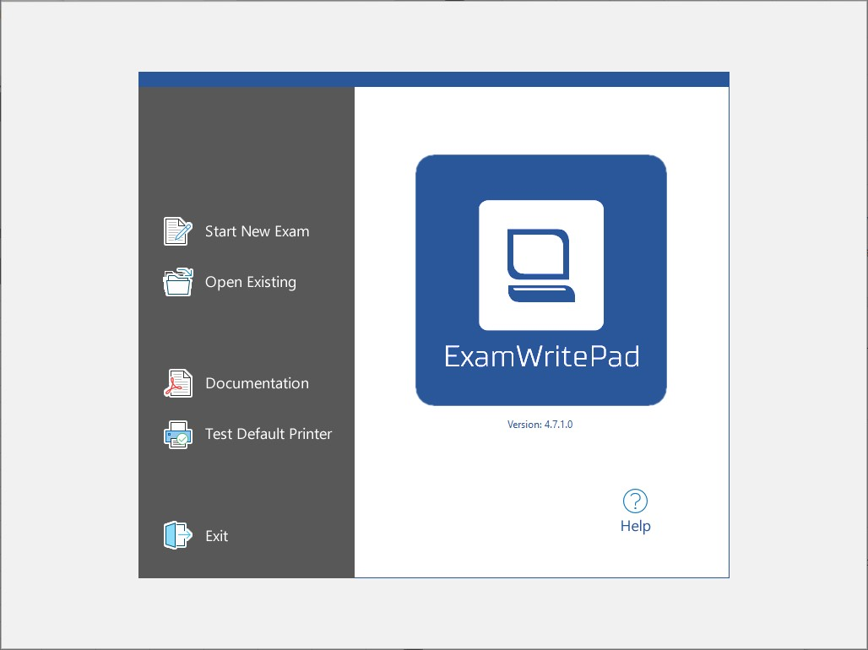
When you login as an exam reader account, there is no Start Menu, Adobe Acrobat will automatically launch in full screen.

Windows Hello
Windows Hello allows you to setup a pin or configure a fingerprint to more quickly log in. This is disabled for all exam accounts, however we have found exam accounts can be prompted to set up Windows Hello.
If you are presented with the message to Use Windows Hello with your account please follow the instructions below to bypass this:
- Click OK in the bottom right hand corner:

- When you see a window saying More information required, close the window by clicking the top right X:
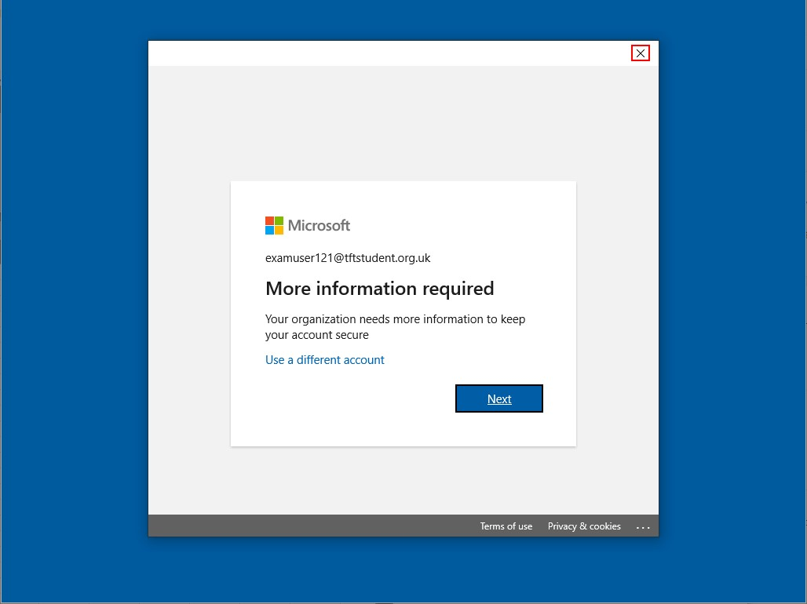
- When you see a message saying Something went wrong, click Skip for now in the bottom right hand corner:


Printing
Printing is not enabled for exam accounts, an exam can be 'printed' to a PDF document and saved to either a USB stick or a dedicated folder C:\Exam:
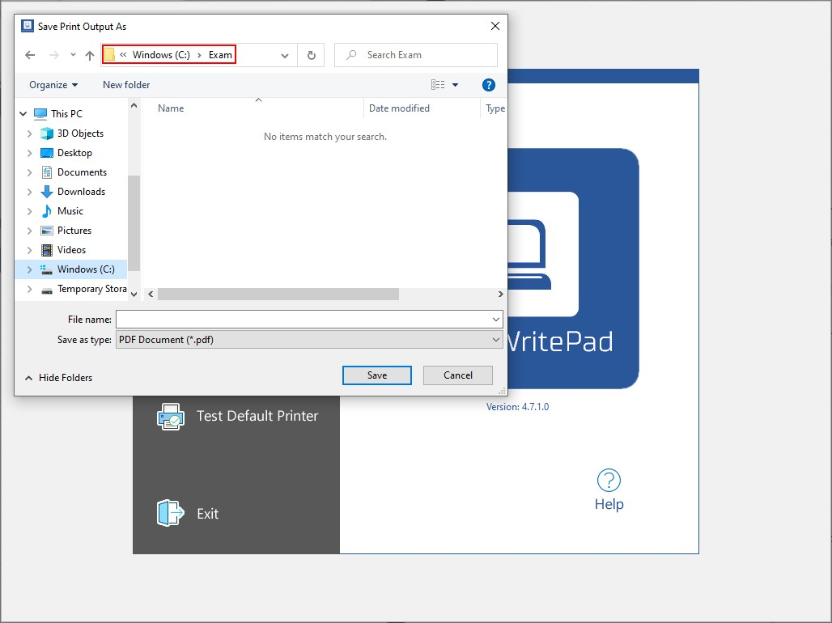
Anything saved in the C:\Exam folder will be accessible by other accounts logging onto the device. This allows the student to take the exam, save the result to C:\Exam and then a teacher can logon and print the PDF to a managed printer.

Logging Out
To logout of an exam account you need to press Ctrl+Alt+Del and select Sign Out:
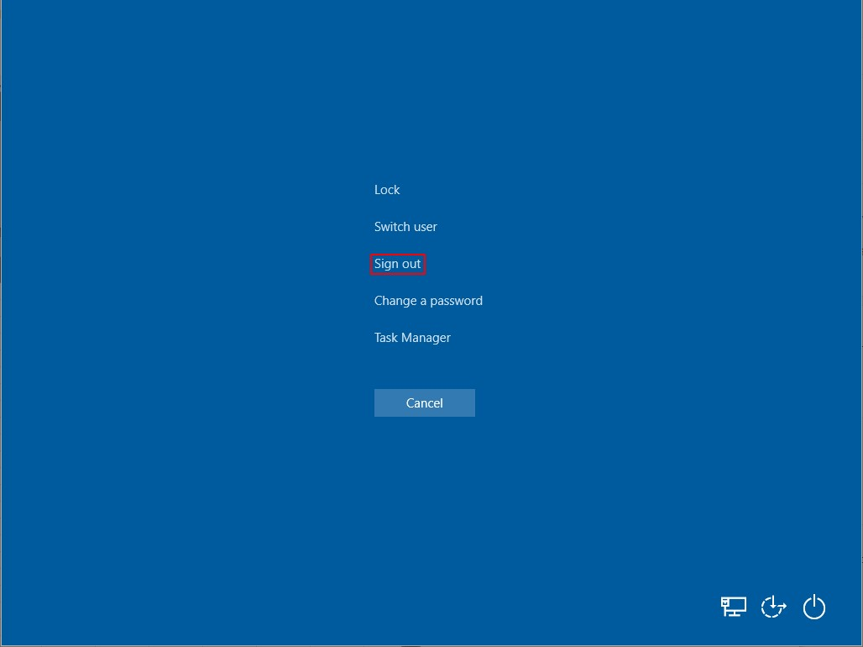

Cleanup
Once an exam is complete and the file has been printed, to remove the exam user profile and delete any files that may be stored in the C:\Exam folder, a teacher can logon to the device and run the Exam Profile Cleanup shortcut in the Start Menu:
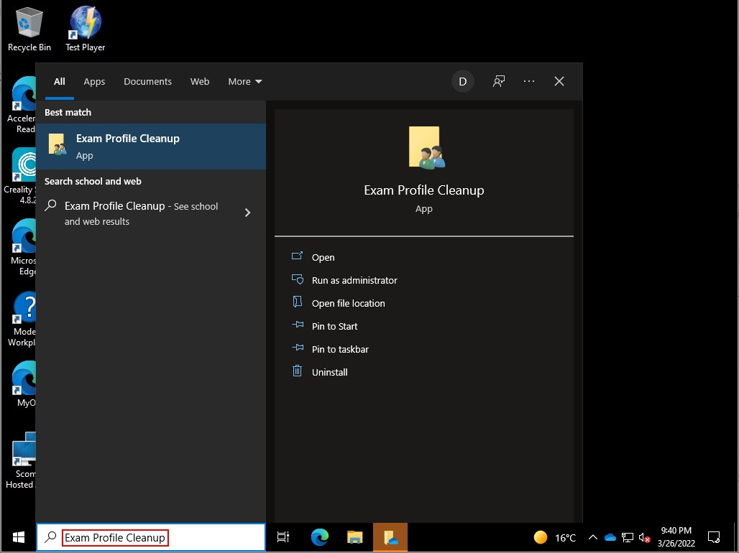
The script can take some time to complete but you can verify the profiles have been deleted by looking in the C:\Users folder:
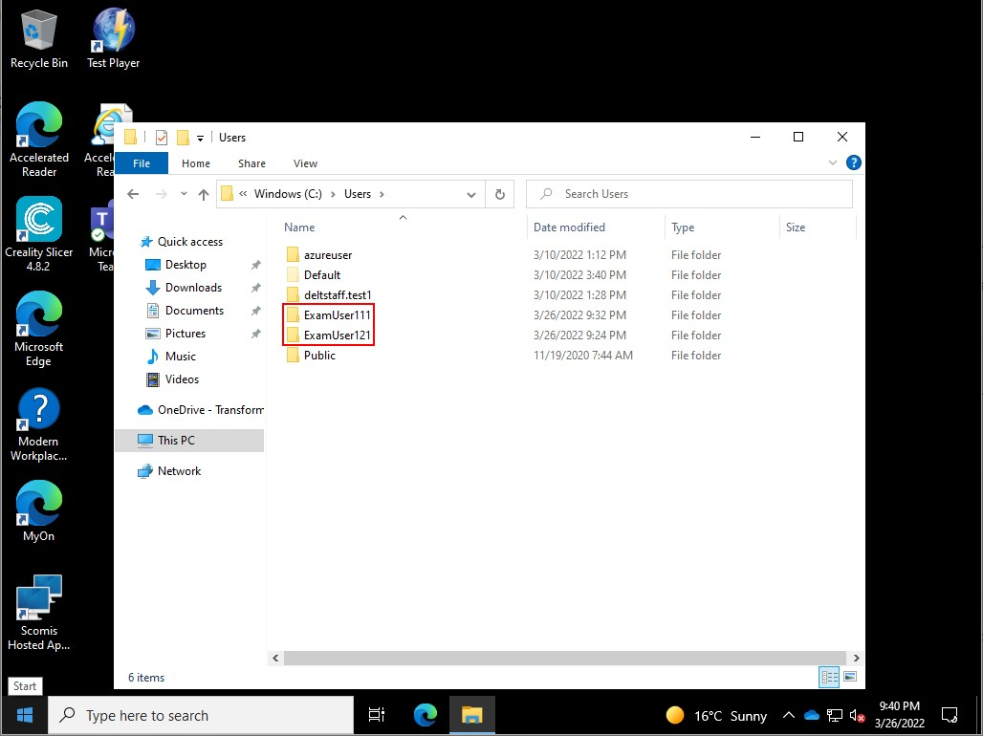
Below shows the profiles have been deleted:
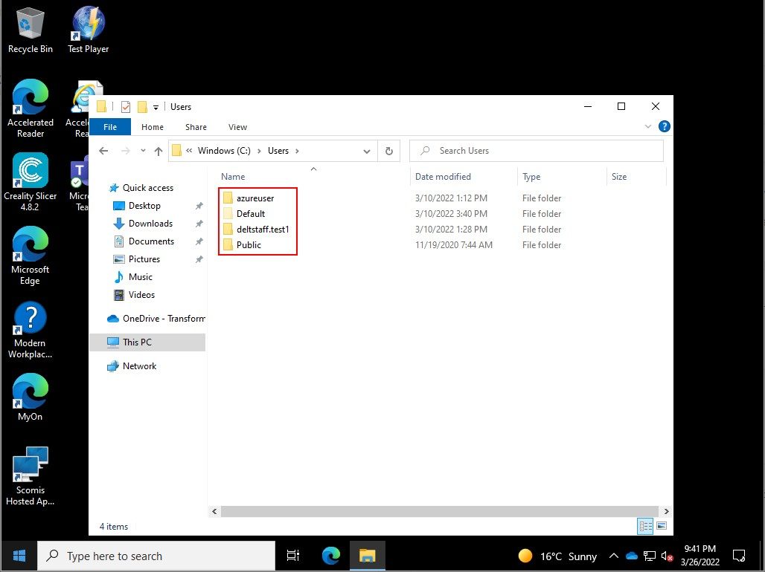

Appendix 2 – Emergency evacuation procedures


Exam Evacuation Procedures

If the Fire Alarm should sound (the sound is a persistent electronic warble type or siren noise) then follow this procedure.
- In the event of the Fire Alarm sounding during an examination (DON’T
PANIC) - all candidates should be instructed to stop writing and close their answer booklets. Leave all question papers, scripts and bags.

- Instruct the candidates to leave the room in silence.

Ensure the candidates are supervised as closely as possible while they are out of the examination room so that there is no discussion about the examination.

- Invigilators should make it clear to candidates that exam conditions will continue until they are told otherwise.

- Make a note of the time of the interruption and how long it lasted.

- Candidates should be kept together and should proceed to the fire assembly point as quickly as possible. Please try and ensure that the candidates are re-assured and remain calm at all times.

- If there are only a few candidates, consider the possibility of taking the candidates (with question papers and scripts) to another place to finish the examination

- If the exam is to be restarted, the time lost should be added to the end of the exam

- Make a full report of the incident and of the action taken, and give to the exams office.
FOR CENTRE USE ONLY
Date received
Reference No.

Appendix 3 - Internal Appeals form
Please tick box to indicate the nature of your appeal and complete all white boxes* on the form below
- Appeal against an internal assessment decision and/or request for a review of marking
- Appeal against a decision to reject candidate’s work on the grounds of malpractice
- Appeal against the centre’s decision not to support a clerical re-check, a review of marking, a review of moderation or an appeal
- Appeal against the centre’s decision relating to access arrangements or special consideration
- Appeal against the centre’s decision relating to an administrative issue
*Where the nature of the appeal does not relate directly to an awarding body’s specific qualification, indicate N/A in awarding body specific detail boxes

Name of appellant |  | Candidate name if different to appellant
Awarding body |  | Exam paper code
Qualification type  Subject |  | Exam paper title
Please state the grounds for your appeal below:

(If applicable, tick below)
 Where my appeal is against an internal assessment decision I wish to request a review of the centre’s marking
If necessary, continue on an additional page if this form is being completed electronically or overleaf if hard copy being completed
Appellant signature: Date of signature:
This form must be signed, dated and returned to the exams officer on behalf of the head of centre to the timescale indicated in the relevant appeals procedure

Appendix 4 - Complaints form | FOR CENTRE USE ONLY
Appendix 4 - Complaints form | Date received
Please tick box to indicate the nature of your complaint | Reference No.
- Complaint against the centre’s delivery of a qualification
- Complain against the centre’s administration of a qualification
Name of complainant
Candidate name (if different to complainant)
Please state the grounds for your complaint below:

If your grounds are lengthy, please write as bullet points; please keep to the point and include relevant detail such as dates, names etc. and provide any evidence you may have to support what you say
If necessary, continue on an additional page if this form is being completed electronically or overleaf if hard copy being completed
Detail any steps you have already taken to resolve the issue(s) and what you would consider to be a good resolution to the issue(s)

Complainant signature: Date of signature:

Appendix 5 - Complaints and Appeals log
On receipt, all complaints/appeals are assigned a reference number and logged. Outcome and outcome date is also recorded.
The outcome of any review of the centre’s marking will be made known to the head of centre. A written record of the review will be kept and logged as an appeal, so information can be easily made available to an awarding body upon request. The awarding body will be informed if the centre does not accept the outcome of a review – this will be noted on this log.
Ref No. | Date received | Complaint or Appeal | Outcome | Outcome date

